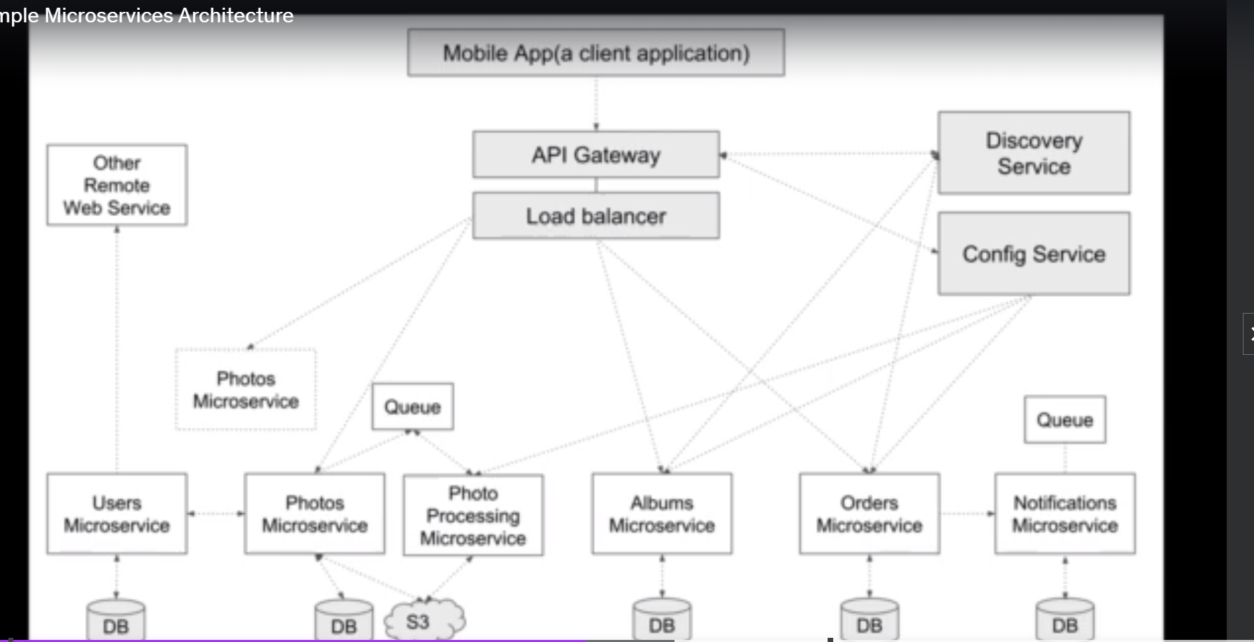

Spring boot project can be created from IDE or from springintializer.

Rest:

Check mobile-app code base

https://www.appsdeveloperblog.com/restful-web-services/restful-web-services-with-spring-mvc/

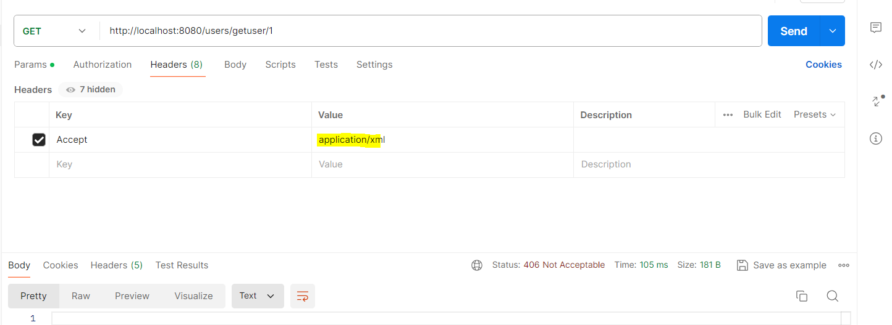

To receive response as specific format, we need to mention the format in the headers asshown above accept header used.

But by using ths accept header server will not give the response as xml and it will give 406 exeption.

To generate the server specified response we need to provide the response type ny using produces as show below

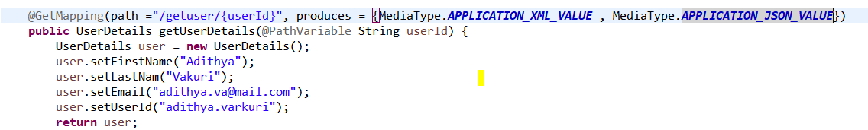

Even afer adding above produces response will nt generate xml output.

We need to add the format dependency for converting the json to sml.

<dependency>

<groupId>com.fasterxml.jackson.dataformat</groupId>

<artifactId>jackson-dataformat-xml</artifactId>

<version>2.11.2</version>

</dependency>

**Send httpresponse code from server**

You need to send response entity as below.

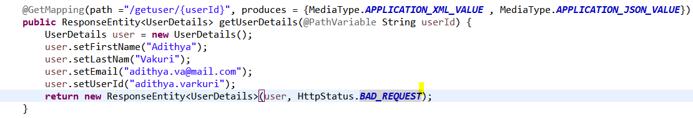

**POST**

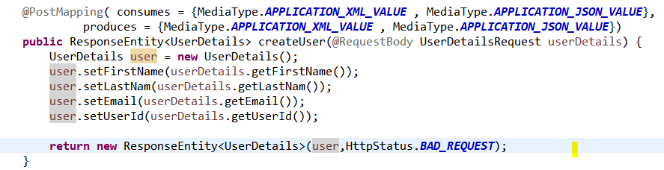

Add consumes and produces for inut and output. By using @requestbody get the body provided in the request.

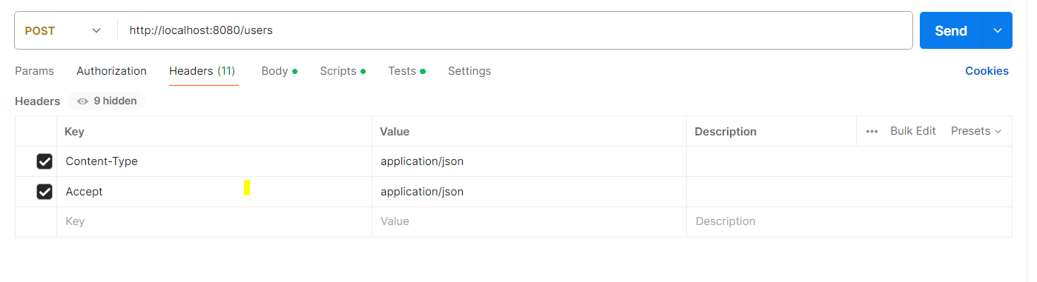

Content-type is used to consume the body,

Accept is used to generate the response.

Accept will be the output, content-type is the input

**Validations**

[**https://www.appsdeveloperblog.com/validate-request-body-in-restful-web-service/**](https://www.appsdeveloperblog.com/validate-request-body-in-restful-web-service/)

**Handling exceptions**

If errors are not handled in the server then it will return 500 internal server error.

In spring we can handle this error messages and can send same format for all the exceptions.

For that we need to create one class which can handle any exception.

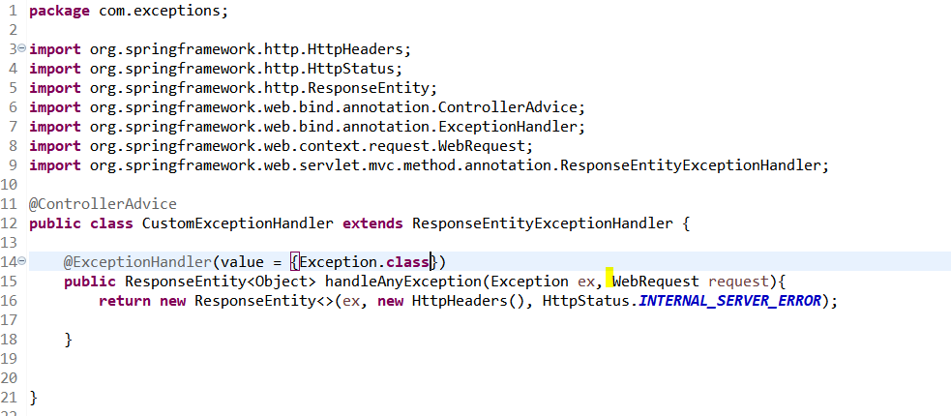

The @ControllerAdvice and @ExceptionHandler annotations are powerful tools for handling exceptions in Spring Boot. They allow you to specify a method that will be called whenever a specific exception is thrown in your application.

The @ControllerAdvice annotation is used to define a class that will be called whenever an exception is thrown in your application. This class can contain multiple methods, each of which is annotated with the @ExceptionHandler annotation and is responsible for handling a specific exception.

To get the specific error message with out other extra stuff. Create the custome classs and add the required msg to that class and send that class as the response.

**RUN spring boot application**

Mvn install will build and generate jar.

In target file jar file will be generated. To run the jar file use below command.

Java -jar abc.jar

## Eureka discovery service

Netflix created this eureka model so it is called as Netflix eureka.

Eureka is used to identify the other mucroservices.

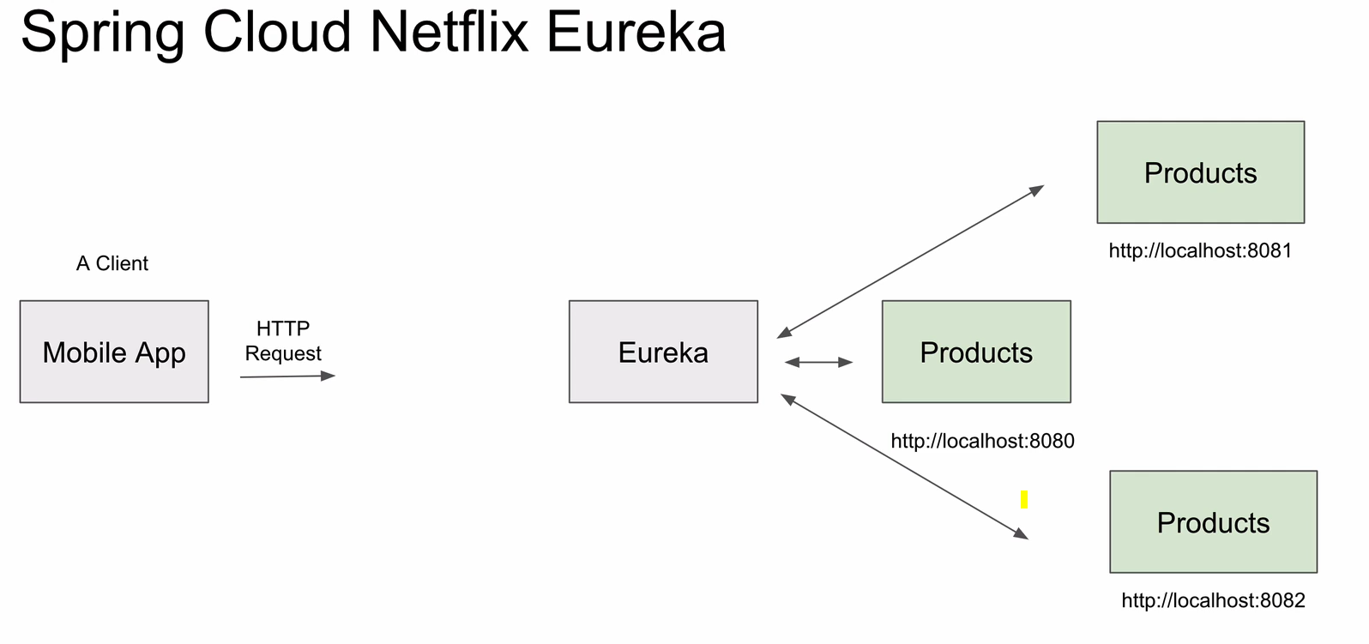

In above image. When mobile app sends request to products urls it will directly hit the producs url on the port. But what if different instances of proudcts are generated because of huge demand then to which url will mobile app hit.

To solve this eureka will come into picture. When ever a microservice is intantiated then it will register with the eureka. So eurekawill have all the details if instances. Request will directly go to eureka and from eureka it will get the products ursl and will go to that url.

Same way when ever products service is deinstanted then automatically it will deregister from the eureka so that it cant be reached.

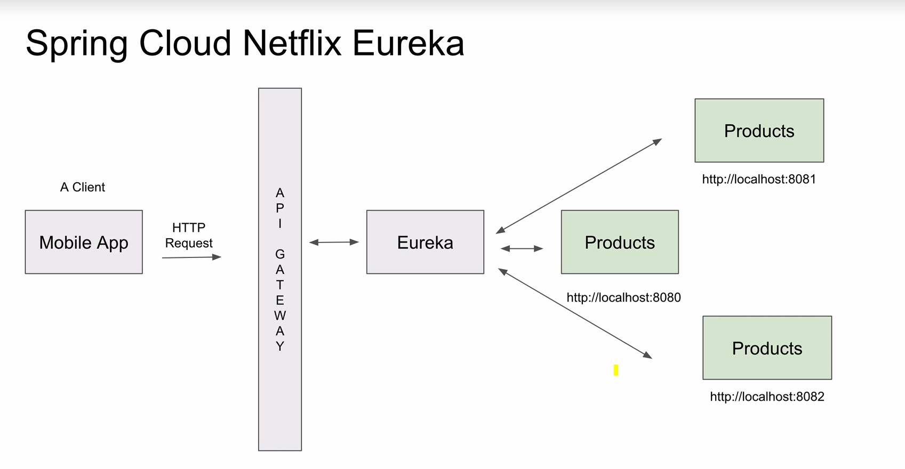

In between we have apigateway.

Eureka server and eurka client.

Eureka server is the server where all microservices will register. And eureka client is the microservice which will register to eureka.

Eurka server will act as server and client, because eureka sever will try to register to other eureka servers.

@Enableeurekaserver:  
to work application as eureka annotate the bootapplicatin class as enableeurekaserver.

Below properties need to set

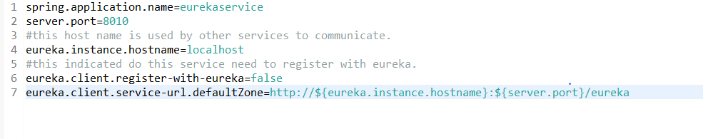

After starting eureka and access theeureka url will get below page.

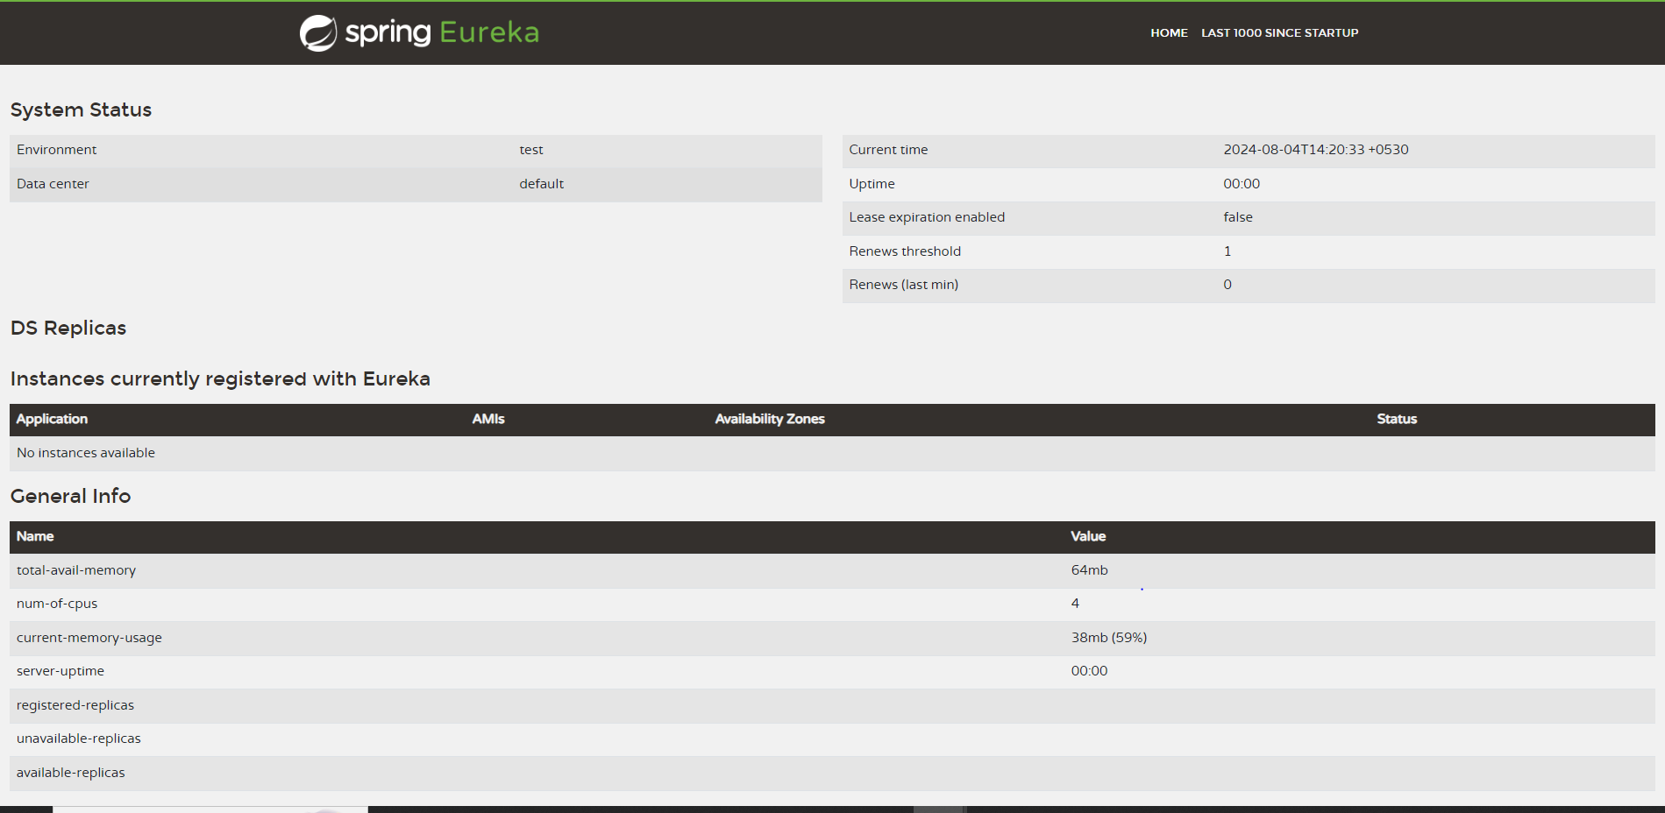

For client side add @EnableDiscoveryClient at the boot class this class will boot application as client.

For client server to work add below prperties

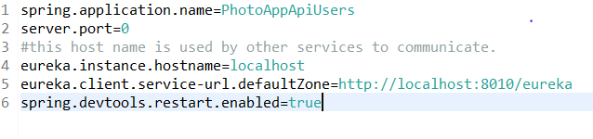

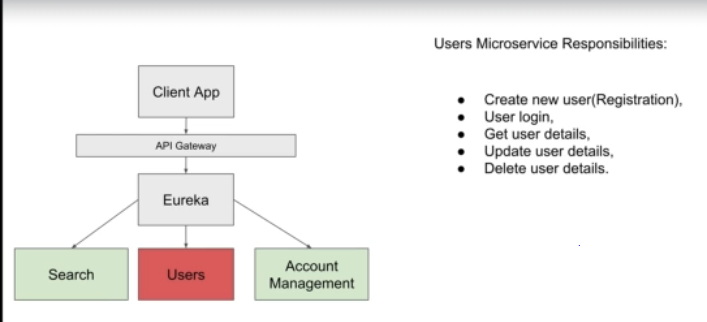

# Spring cloud API gateway

When multiple instances of the service is running then we need to load balance the request among the instances.

API gate way will receive the request from the client. And gets the service details from eureka and transfers the request to services.

We can add filters or logs for the APIgateway.

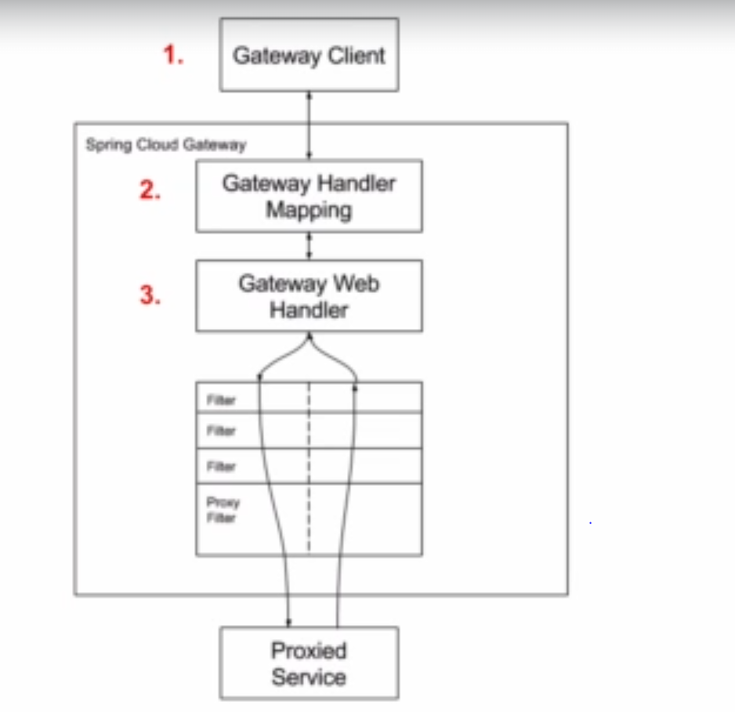

spring.cloud.gateway.discovery.locator.enabled=true



when we enable above property pigateway will automatically route the request.

After creating apigateway use <http://localhost:8082/photoappapiusers/users/status/check> url to acess the app.

For routes add below properties

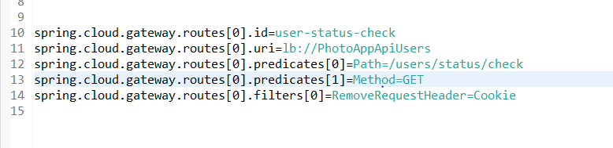

After adding the properties url will be as below with out any microservice name

<http://localhost:8082/users/status/check>.

Rewriting url

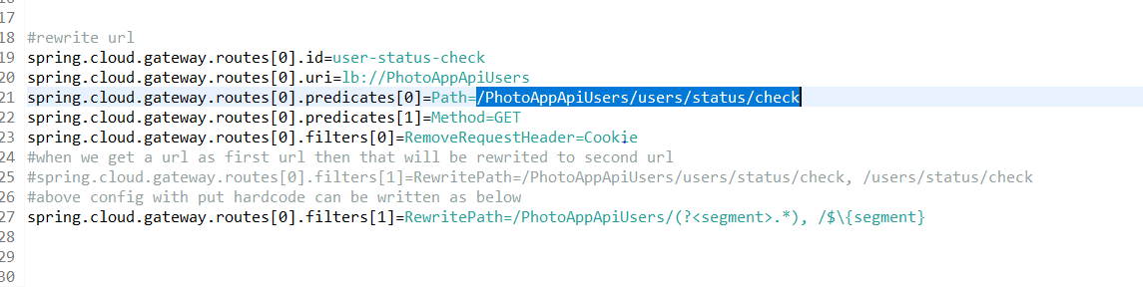

url will be

<http://localhost:8082/PhotoAppApiUsers/users/status/check>.

**Build-In Predicate Factories in Spring Cloud API Gateway**

#### **Built-in Route Predicate Factories in Spring Cloud API Gateway**

Below is a list of built-in predicates that you can use when creating routes in Spring Cloud API Gateways. These are built-in predicates and you do not need to write any additional Java code for them to work.

Note: The description of the following built-in predicates is taken from the [Spring Cloud API Gateway documentation page](https://cloud.spring.io/spring-cloud-gateway/reference/html/#gateway-request-predicates-factories).

**1. The After Route Predicate Factory**

The After route predicate factory takes one parameter, a datetime (which is a java ZonedDateTime). This predicate matches requests that happen after the specified datetime. The following example configures an after route predicate:

1. spring.cloud.gateway.routes[0].id = after_route
2. spring.cloud.gateway.routes[0].uri = https://example.org
3. spring.cloud.gateway.routes[0].predicates[0] = After=2017-01-20T17:42:47.789-07:00[America/Denver]

This route matches any request made after Jan 20, 2017 17:42 Mountain Time (Denver).

**2. The Before Route Predicate Factory**

The Before route predicate factory takes one parameter, a datetime (which is a java ZonedDateTime). This predicate matches requests that happen before the specified datetime. The following example configures a before route predicate:

1. spring.cloud.gateway.routes[0].id = before_route
2. spring.cloud.gateway.routes[0].uri = https://example.org
3. spring.cloud.gateway.routes[0].predicates[0] = Before=2017-01-20T17:42:47.789-07:00[America/Denver]

This route matches any request made before Jan 20, 2017 17:42 Mountain Time (Denver).

**3. The Between Route Predicate Factory**

The Between route predicate factory takes two parameters, datetime1 and datetime2 which are java ZonedDateTimeobjects. This predicate matches requests that happen after datetime1 and before datetime2. The datetime2 parameter must be after datetime1. The following example configures a between route predicate:

1. spring.cloud.gateway.routes[0].id = between_route
2. spring.cloud.gateway.routes[0].uri = https://example.org
3. spring.cloud.gateway.routes[0].predicates[0] = Between=2017-01-20T17:42:47.789-07:00[America/Denver], 2017-01-21T17:42:47.789-07:00[America/Denver]

This route matches any request made after Jan 20, 2017 17:42 Mountain Time (Denver) and before Jan 21, 2017 17:42 Mountain Time (Denver). This could be useful for maintenance windows.

**4. The Cookie Route Predicate Factory**

The Cookie route predicate factory takes two parameters, the cookie name and a regexp (which is a Java regular expression). This predicate matches cookies that have the given name and whose values match the regular expression. The following example configures a cookie route predicate factory:

1. spring.cloud.gateway.routes[0].id = cookie_route
2. spring.cloud.gateway.routes[0].uri = https://example.org
3. spring.cloud.gateway.routes[0].predicates[0] = Cookie=chocolate, ch.p

This route matches requests that have a cookie named chocolate whose value matches the ch.p regular expression.

**5. The Header Route Predicate Factory**

The Header route predicate factory takes two parameters, the header name and a regexp (which is a Java regular expression). This predicate matches with a header that has the given name whose value matches the regular expression. The following example configures a header route predicate:

1. spring.cloud.gateway.routes[0].id = header_route
2. spring.cloud.gateway.routes[0].uri = https://example.org
3. spring.cloud.gateway.routes[0].predicates[0] = Header=X-Request-Id, \d+

This route matches if the request has a header named X-Request-Id whose value matches the \d+ regular expression (that is, it has a value of one or more digits).

**6. The Host Route Predicate Factory**

The Host route predicate factory takes one parameter: a list of host name patterns. The pattern is an Ant-style pattern with . as the separator. This predicates matches the Host header that matches the pattern. The following example configures a host route predicate:

1. spring.cloud.gateway.routes[0].id = host_route
2. spring.cloud.gateway.routes[0].uri = https://example.org
3. spring.cloud.gateway.routes[0].predicates[0] = Host=**.somehost.org,**.anotherhost.org

URI template variables (such as {sub}.myhost.org) are supported as well.

This route matches if the request has a Host header with a value of www.somehost.org or beta.somehost.org or www.anotherhost.org.

This predicate extracts the URI template variables (such as sub, defined in the preceding example) as a map of names and values and places it in the ServerWebExchange.getAttributes() with a key defined in ServerWebExchangeUtils.URI_TEMPLATE_VARIABLES_ATTRIBUTE. Those values are then available for use by [GatewayFilterfactories](https://cloud.spring.io/spring-cloud-gateway/reference/html/#gateway-route-filters)

**7. The Method Route Predicate Factory**

The Method Route Predicate Factory takes a methods argument which is one or more parameters: the HTTP methods to match. The following example configures a method route predicate:

1. spring.cloud.gateway.routes[0].id = method_route
2. spring.cloud.gateway.routes[0].uri = https://example.org
3. spring.cloud.gateway.routes[0].predicates[0] = Method=GET,POST

This route matches if the request method was a GET or a POST.

**8. The Path Route Predicate Factory**

The Path Route Predicate Factory takes two parameters: a list of Spring PathMatcher patterns and an optional flag called matchOptionalTrailingSeparator. The following example configures a path route predicate:

1. spring.cloud.gateway.routes[0].id = path_route
2. spring.cloud.gateway.routes[0].uri = https://example.org
3. spring.cloud.gateway.routes[0].predicates[0] = Path=/red/{segment},/blue/{segment}

This route matches if the request path was, for example: /red/1 or /red/blue or /blue/green.

This predicate extracts the URI template variables (such as segment, defined in the preceding example) as a map of names and values and places it in the ServerWebExchange.getAttributes() with a key defined in ServerWebExchangeUtils.URI_TEMPLATE_VARIABLES_ATTRIBUTE. Those values are then available for use by [GatewayFilterfactories](https://cloud.spring.io/spring-cloud-gateway/reference/html/#gateway-route-filters)

**9. The Query Route Predicate Factory**

The Query route predicate factory takes two parameters: a required param and an optional regexp (which is a Java regular expression). The following example configures a query route predicate:

1. spring.cloud.gateway.routes[0].id = query_route
2. spring.cloud.gateway.routes[0].uri = https://example.org
3. spring.cloud.gateway.routes[0].predicates[0] = Query=green

The preceding route matches if the request contained a green query parameter.

**10. The RemoteAddr Route Predicate Factory**

The RemoteAddr route predicate factory takes a list (min size 1) of sources, which are CIDR-notation (IPv4 or IPv6) strings, such as 192.168.0.1/16 (where 192.168.0.1 is an IP address and 16 is a subnet mask). The following example configures a RemoteAddr route predicate:

1. spring.cloud.gateway.routes[0].id = remoteaddress_route
2. spring.cloud.gateway.routes[0].uri = https://example.org
3. spring.cloud.gateway.routes[0].predicates[0] = RemoteAddr=192.168.1.1/24

This route matches if the remote address of the request was, for example, 192.168.1.10.

**11. The Weight Route Predicate Factory**

The Weight route predicate factory takes two arguments: group and weight (an int). The weights are calculated per group. The following example configures a weight route predicate:

1. spring.cloud.gateway.routes[0].id = weight_high
2. spring.cloud.gateway.routes[0].uri = https://example.org
3. spring.cloud.gateway.routes[0].predicates[0] = Weight=group1, 8
5. spring.cloud.gateway.routes[1].id = weight_low
6. spring.cloud.gateway.routes[1].uri = https://example.org
7. spring.cloud.gateway.routes[1].predicates[0] = Weight=group1, 2

This route would forward ~80% of traffic to [weighthigh.org](https://weighthigh.org/) and ~20% of traffic to [weighlow.org](https://weighlow.org/)

**Gateway Filters in Spring Cloud API Gateway**

A list of API Gateway filters is very long to be included in a single lecture. Below are direct links to gateway filters published in Spring Cloud API Gateway documentation.

* [GatewayFilter Factories](https://cloud.spring.io/spring-cloud-gateway/reference/html/#gatewayfilter-factories)
* [Global Filters](https://cloud.spring.io/spring-cloud-gateway/reference/html/#global-filters)
* [HTTPHeadersFilters](https://cloud.spring.io/spring-cloud-gateway/reference/html/#httpheadersfilters)

You can bookmark these pages in your browser for quick access.

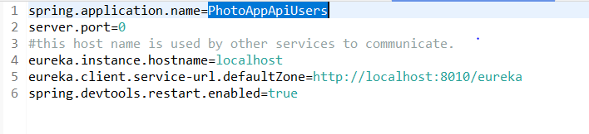

When we use above configuration we gave port no as 0 in this case when ever we run service it will register with the eureka and if multiple instances are ran then it will reregister.so that we can see only one instance.

To fix this add one more property.



By using above property it ill generate the random instance ids as below.

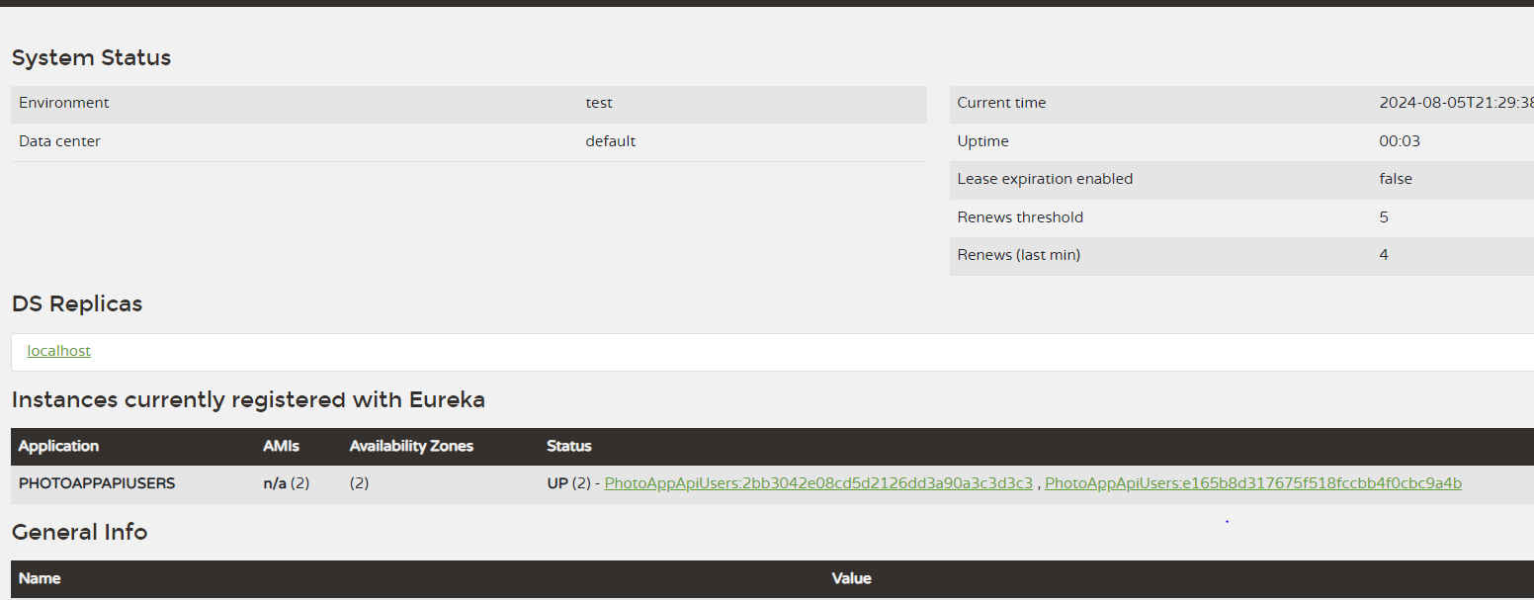

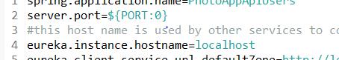

Or we can use port number as above where port number can be provided from command line while starting the app.

mvn spring-boot:run -Dspring-boot.run.arguments=--spring.application.instance_id=adithya

use above command to start spring boot project frm commanadlne argument.

mvn spring-boot:run -Dspring-boot.run.arguments=--spring.application.instance_id=adithya, --server.port=8999

# H2 in memory database

# Password encrypt spring security

To encrypt password we need spring security.

When ever we add below security dependency in the pom then automatically application will ask for authentication.

<dependency>

<groupId>org.springframework.boot</groupId>

<artifactId>spring-boot-starter-security</artifactId>

</dependency>

To add custome security add the class as shown below. Whnen @enablewebsecurity annotation is added then spring will create object for websecurity class and updates in the context.

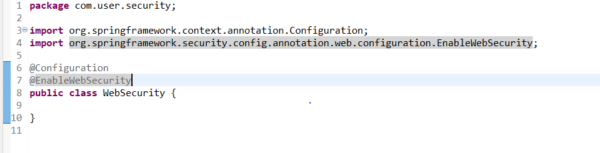

As shown below security filter chain is created and when ever application is sarted then spring will create filter using this method and puts these security configurations in the application context.

When ever we get a request it will pass through all the filters and also passe through this sexurity filer and will check if all the access configured in the method is available for the request.

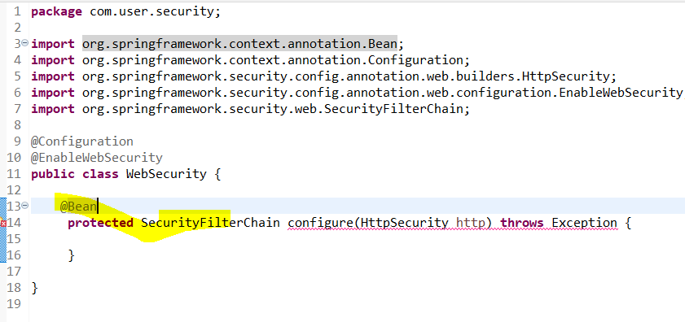

Below configuration is added.

CSRF protects against what is aptly titled a Cross Site Request Forgery. In this type of attack, a token such as a session ID, is stored in the browser's cookies. The default behavior is to send the cookies with a request to a site. Someone can exploit this default behavior to impersonate you and do malicious things.

Here's how it works:

CSRF protects against what is aptly titled a Cross Site Request Forgery. In this type of attack, a token such as a session ID, is stored in the browser's cookies. The default behavior is to send the cookies with a request to a site. Someone can exploit this default behavior to impersonate you and do malicious things.

Here's how it works:

(this example carped from the Spring Security Reference docs: <https://docs.spring.io/spring-security/site/docs/5.3.x/reference/html5/#csrf>)

Your bank has a website and on this website there's a mechanism to transfer money. You login and transfer a little money. You forget to logout. Then you navigate to an evil website.

The evil website duplicates this form and sends a request to transfer 100 bucks from your account to theirs. They can't see the cookie but the cookies are sent with the request. They don't have to see the key in order to turn the key in the lock. Because you forgot to logout, your Session ID is still active (typically they expire but sometimes they don't want to burden their customers with logging in every time).

The bank can't tell who sent the request, and they certainly can't block all malicious websites since there are probably more malicious sites than legitimate ones out there.

So, the bank enables CSRF protection which requires a special token to be generated for the request. The token will be embedded in the request and won't be stored in a cookie. Without this token, the request will rejected.

Next add the request matchers. As shown below when post request comes with /users we are permiting all.

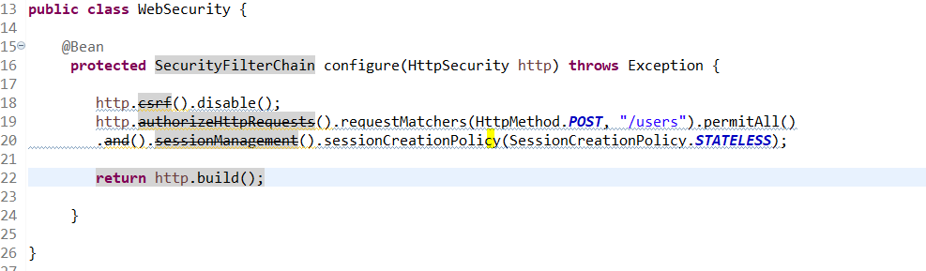

# Encrypt password

Use BCryptPasswordEncoder for encrypting

Create this bean in configuration class

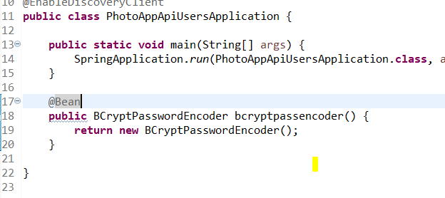

Security to allow only the API gateway ip address.

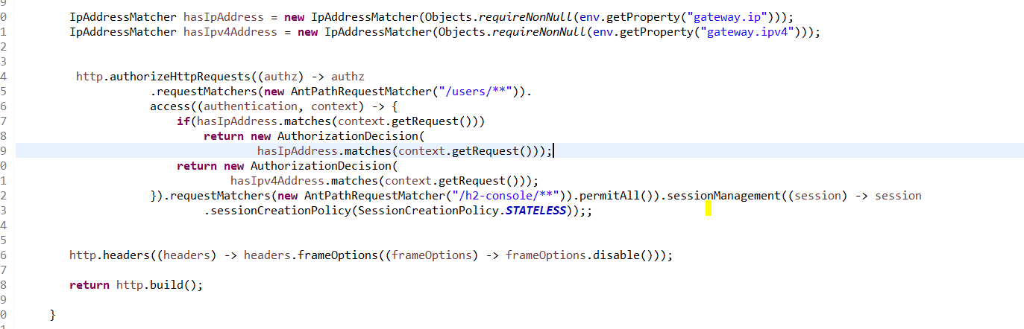

# UserLogin or siginup or authentication

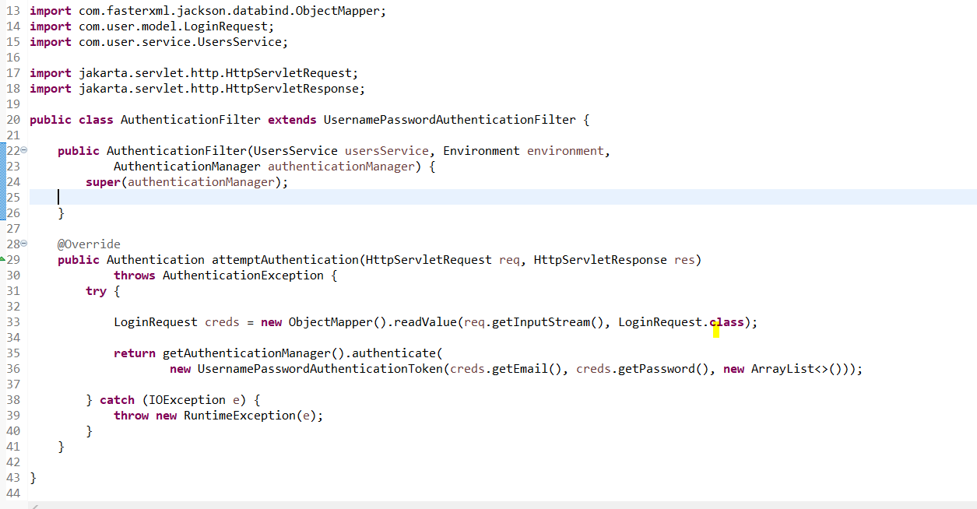

Above filter is used to authenticate the user details.

Springwill register this filter and ill be called when triggered. User details will be read and stored in the creds. And using authenticate method t will authenticate the user details.

When application triggeres login then sprig will trigger the attemptauthentication method.

To work this we need to register the filter in the security.

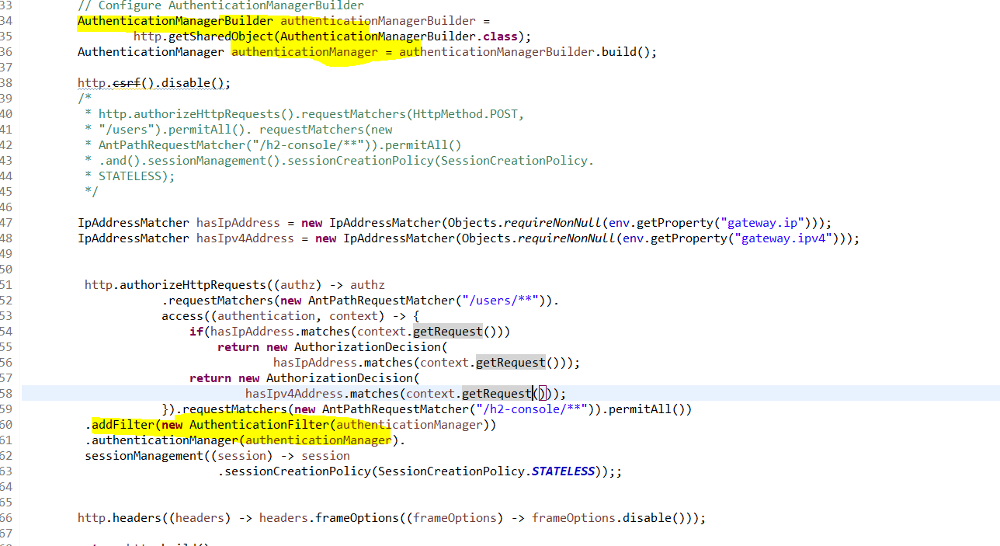

Now in the above filter we have provided the username and password which we got from the UI. But these details should be validated with the userdetails available in the Database. For this we need to configure such that security code will automatically validate from the database.

For this we need to provide the webseurity that from where we will get the userdetails. So here we have passed the userservice where we can get the user details by triggering the databse.

Userservice we need to pass to the authenticationbuilder.

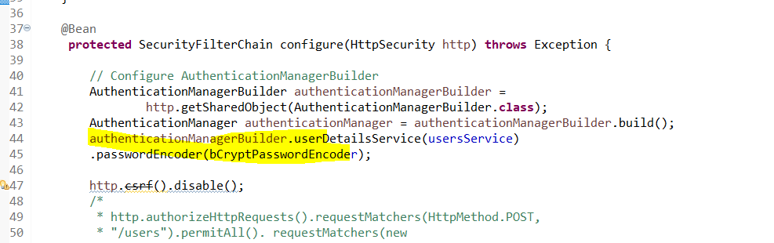

And user service will be extended with userdetailsservice. And method need to be implemented in user service impl.

This method will trigger the databse and will fetch the userdetails and will return the User object.

Then spring security will valdate the UI details with userdetails from the databse.

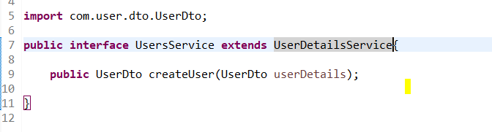

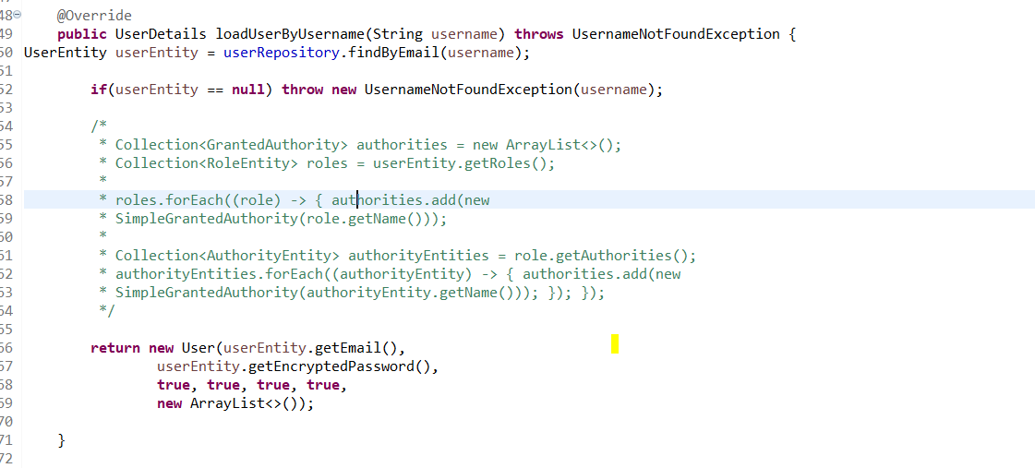

Next after successfully authenticating the userdetails, security code will automatically trigger the successfulAuthentication method in the authenticationfilter.

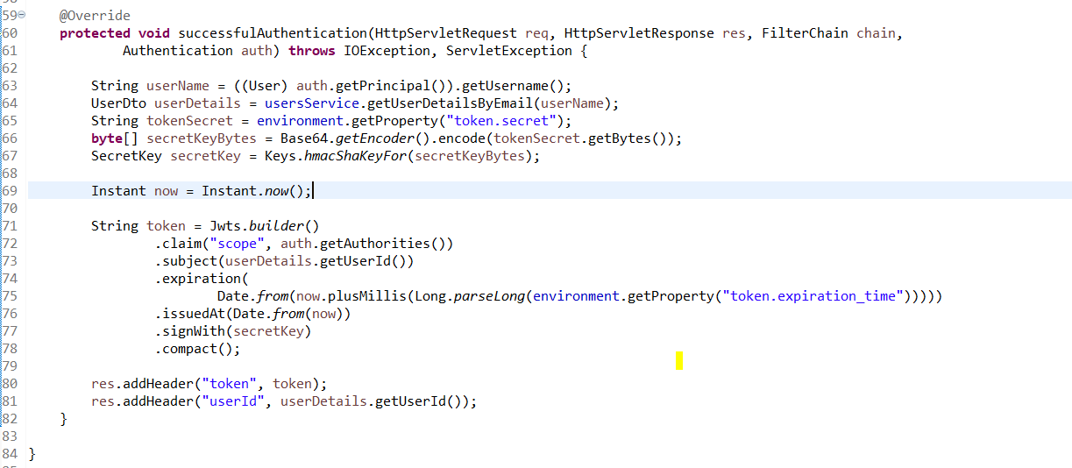

As shown in above method aftersucessfully authenticated it will trigger the sucessfulauthenticationmethod and ill create JWT token and adds it in the headers.

After adding above code just try authenticating.

We have used /login for authenticating. We can customize the authentication url.

To use the custom login url we need to add the filter with login url

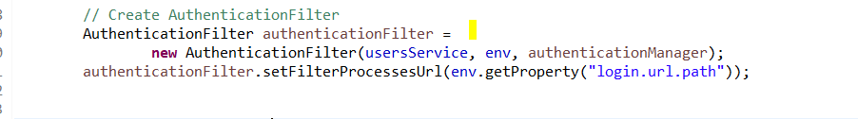

For the existing filter add the filterprocessurl as shown above.

login.url.path = /users/login

Now use below url for login

<http://localhost:8082/photoappapiusers/users/login>

If apigateway t locate the url automatically then use

spring.cloud.gateway.discovery.locator.enabled=true

If we need to add filters or headers then use below config

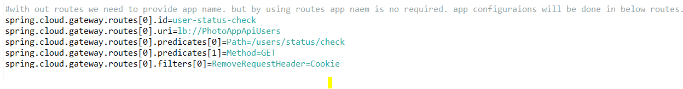

For rewriting the url use below

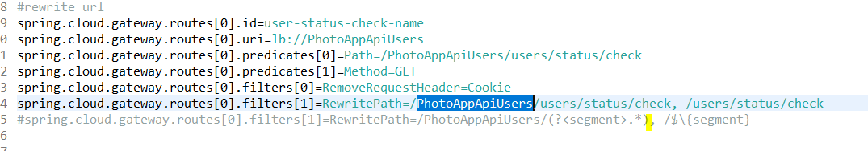

## Validate Token Filter

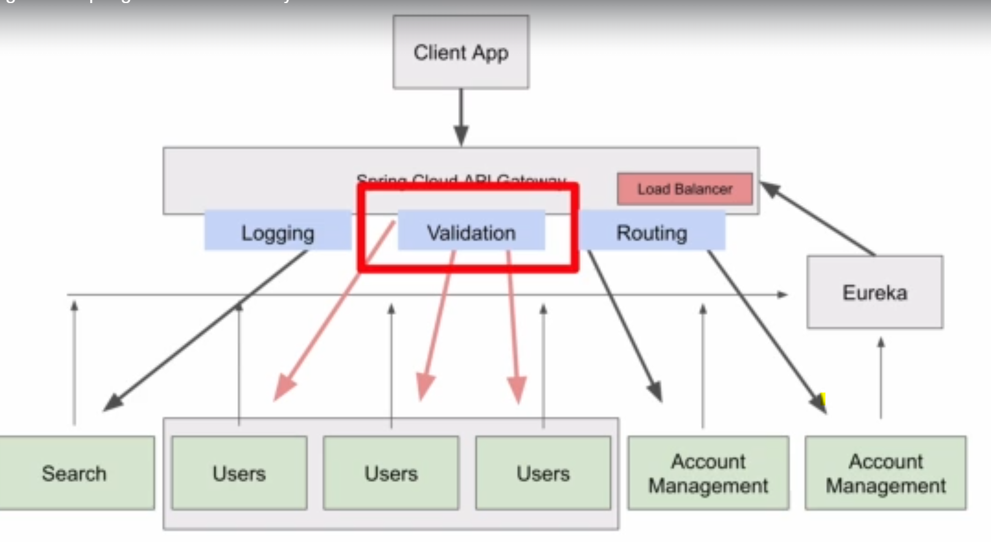

Once we get the token, we need to send the token in every request. And token validation need to be done for every request and if token is valid then accept the request else drop the request.

spring.cloud.gateway.routes[0].predicates[2]=Header

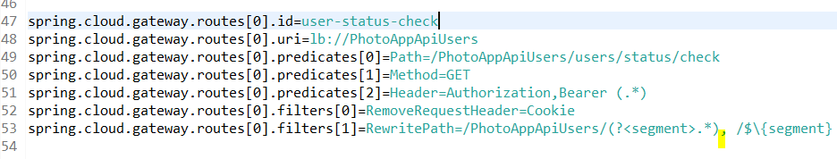

For each request we need to ensure that token header is included. If token is not included then discard the request.

To do above thing we need to add the predicate as shown above.’

spring.cloud.gateway.routes[0].predicates[2]=Header=Authorization,Bearer (.*)

request will be allowed only if request contains the Authorization header and that header starting with bearer.

Now for validating the token new filter need to be added.



Next before executing the request we need to execute the filter for that we need to add this filter to gateway router

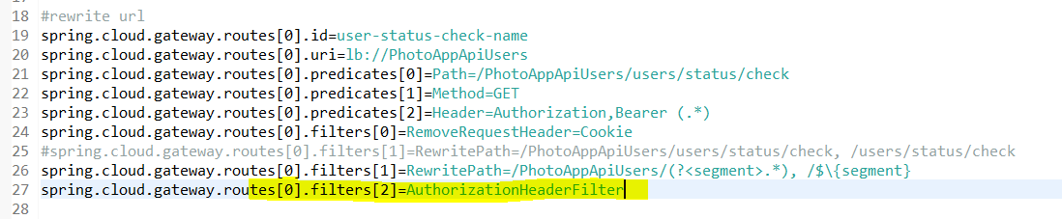

As shown in above filter is applied to this request. So when ever request is made for this url then this filter will trigger.

In the filter apply method will be triggered.

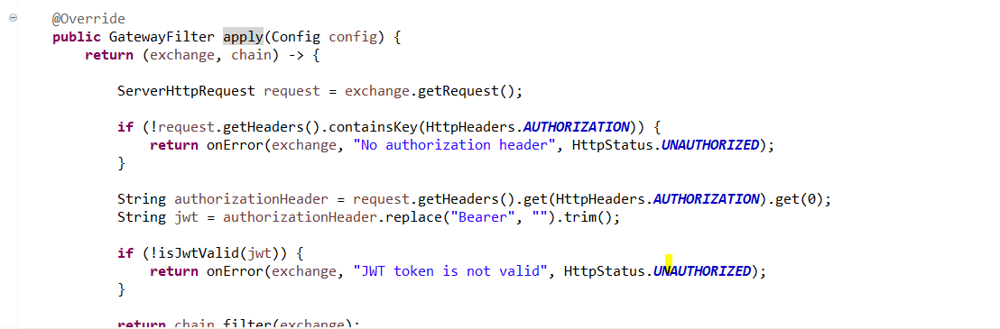

From the exchange object we can read the request object.

Using the chain object we can route our request to next filter in the chain once token is validated.

**Validating the token**

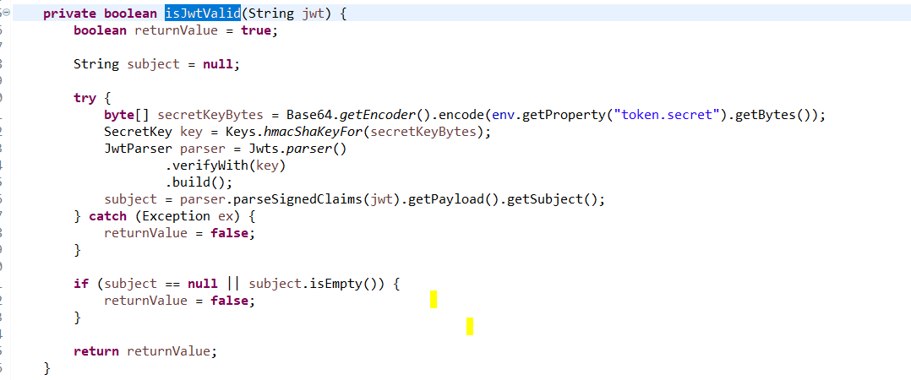

Get the token secret which was used for sign the token when token is generated.

Using token secret generate the signing key and using this signing key validate the token.

## API gateway pre and post filters

While creating this filters implement global filter as shown below.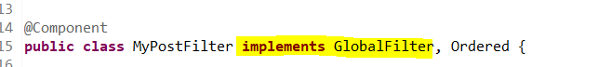

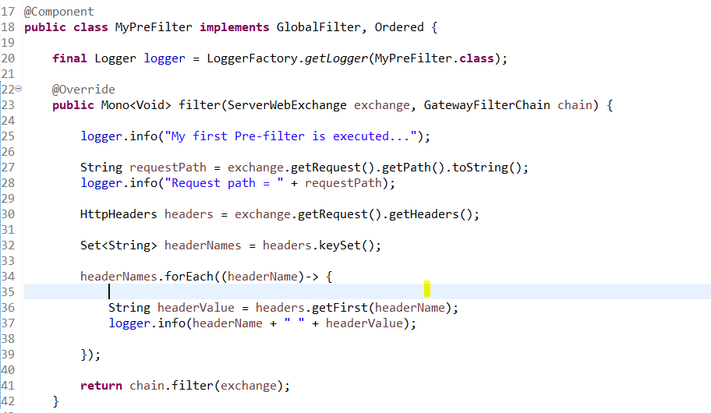

For pre filter is executed before the request method is triggered. And once this filter is completed then it will pass it to next filter in the chain using chain.filter.

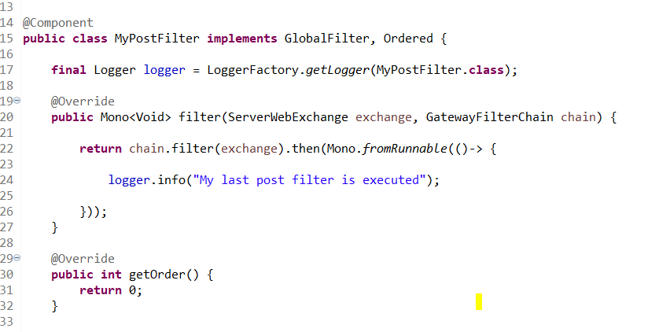

We can create post and prefilters in same class.

For this we need to create filter class and add configuration for this class.

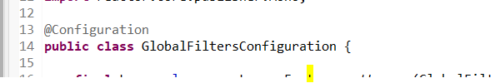

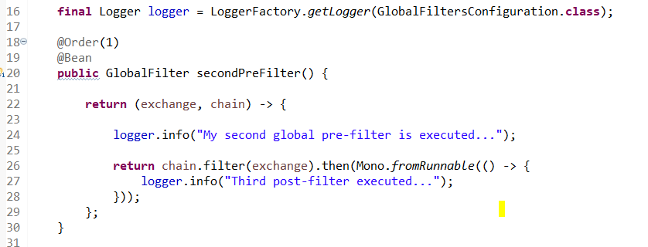

Now to execute the filters in the order we need to provide the order as shown in above img.

Check GlobalFiltersConfiguration class for pre and post filters.

When we create individual filter classes we can provide the order. For this we need to implement the order interface and implement getorder and provide the order as shown below.

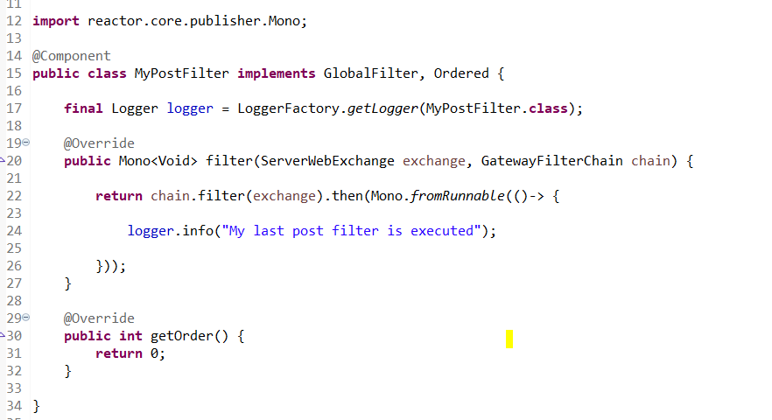

# Spring cloud config server

Till now for each microservice we have different properties file where we will configure the configurations related to that service like port no etc.

Now if for all the microservices some configurations are same for example database details then we need to configure in all the services. But if we need to change the database details then we need to change in all the services and restart the services

which is a complex task.

Now instead of maintaining the configurations in different services the common configurations we can save at one place and using cloud config server we can read the configurations in each service.

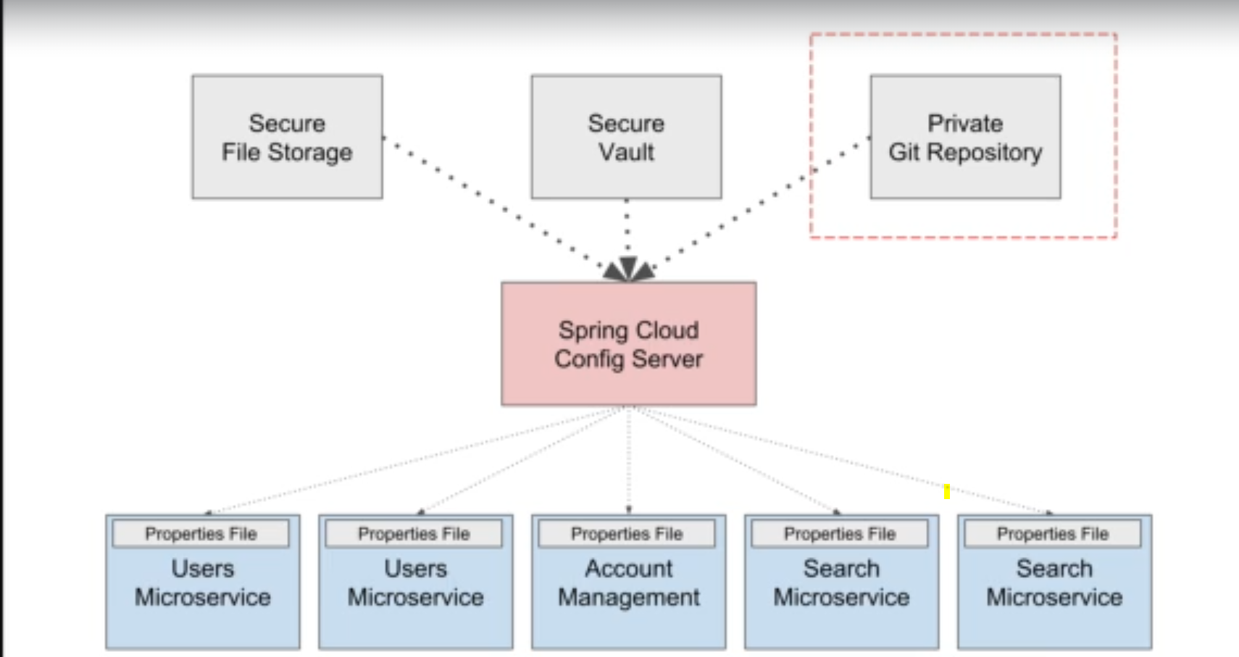

Spring cloud server is also a spring boot application.

For the application to act as an config server annotate the config file as @enableconfigserver.

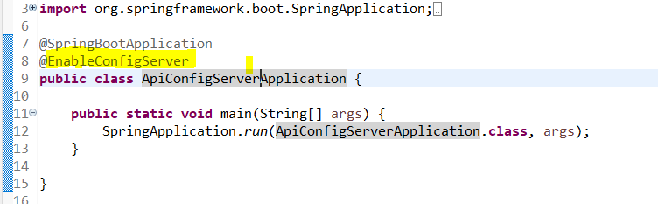

Create a git repository where we can store the properties and from that repository read the properties using cloud server config.

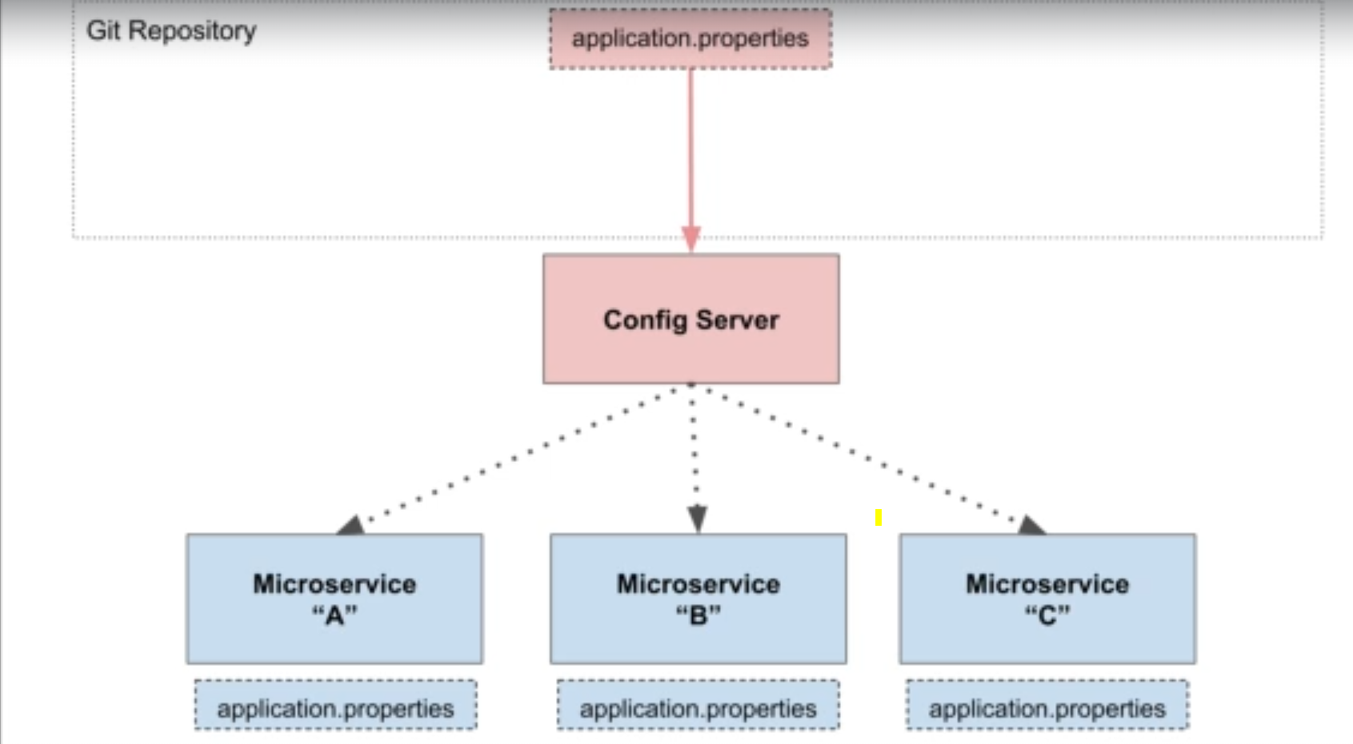

Above image is the configuration for config sserver. After configuring cnfig server now each service can read properties from multiple properties files one is from the local service file and another is from the config server file.

Config server propoerties are the first priority.

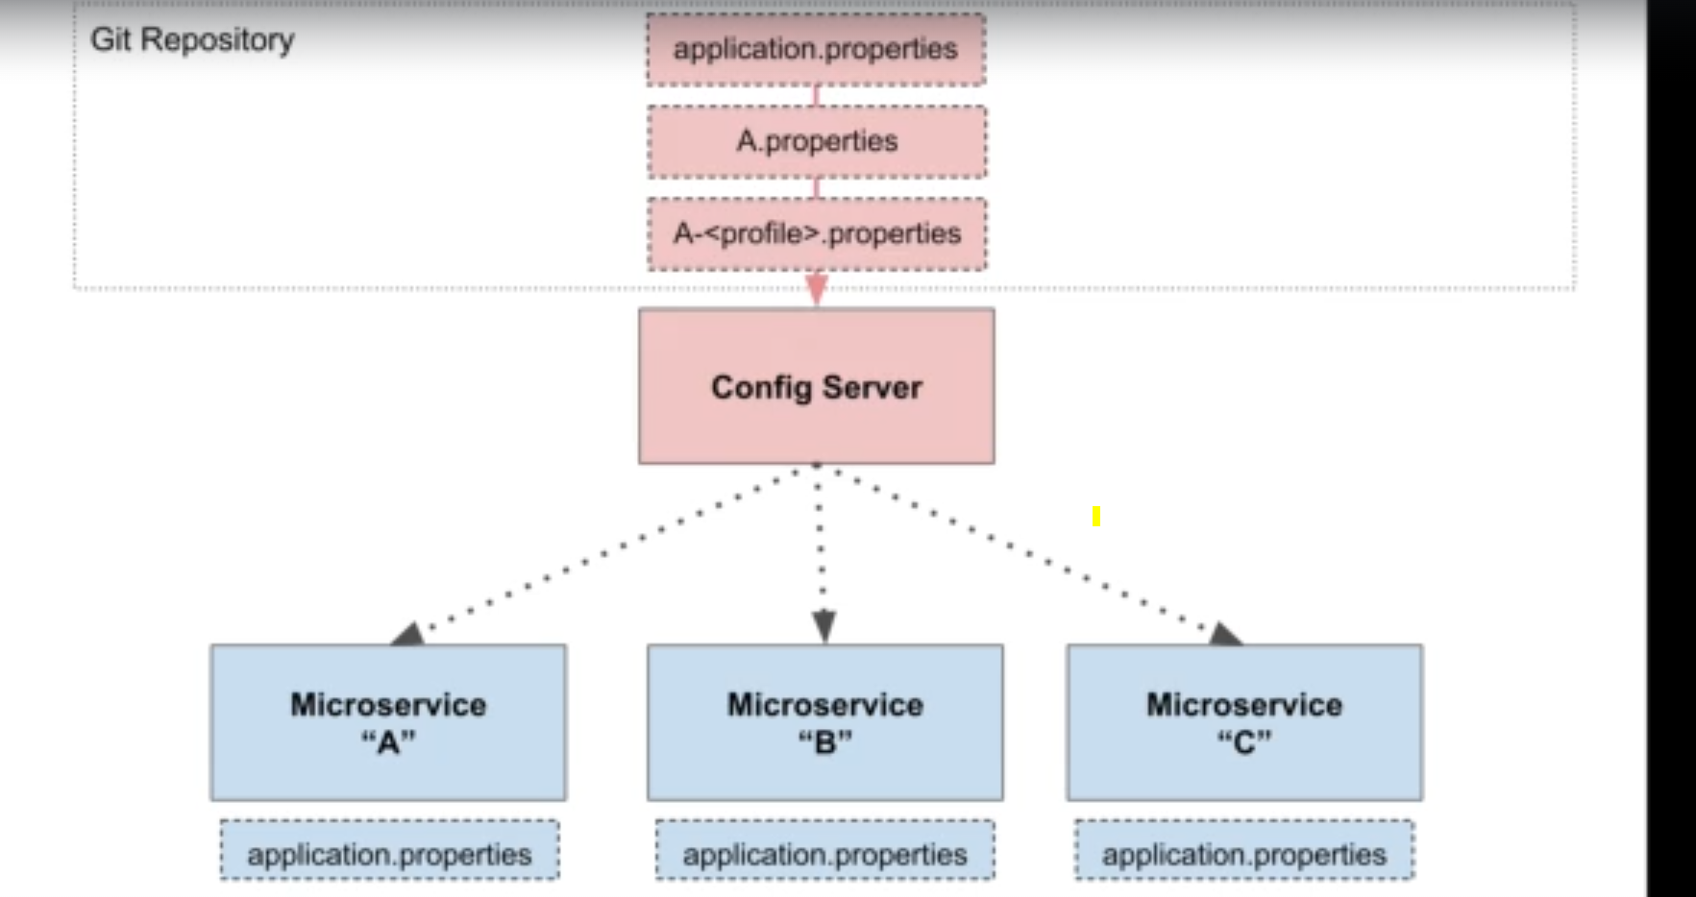

As show in above image a-profile is the first priority when profile is selected and next is the a.prperties file and next is the application.properties and next is the service application.properties.

In the config server need to provide the details of git server

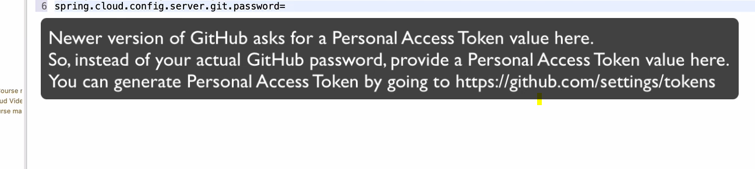

Add the below properties in the config server to connect to git repo

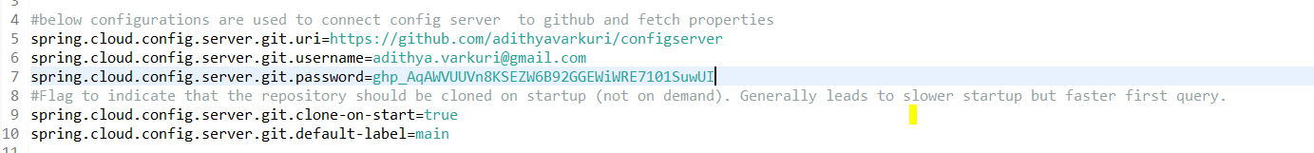

In each service where we need to use the config server just add the below dependency.

<dependency>

<groupId>org.springframework.cloud</groupId>

<artifactId>spring-cloud-starter-config</artifactId>

</dependency>

<dependency>

<groupId>org.springframework.cloud</groupId>

<artifactId>spring-cloud-starter-bootstrap</artifactId>

</dependency>

And to config the server create the bootstratp.properties file and add thebelow properties.

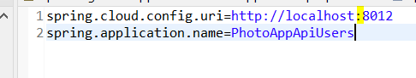

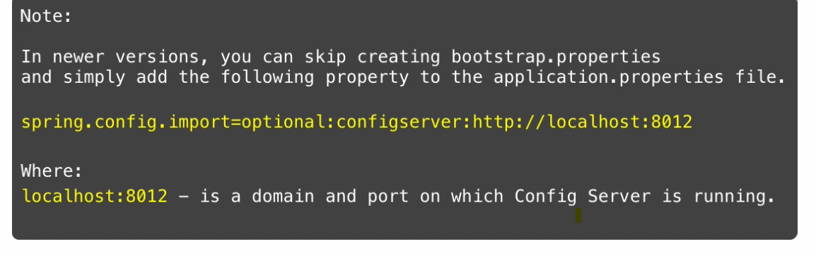

Before the application loading the application.properties file this bootstrap.properties file will be loaded. And this bootstrap file will be loaded even before the beans are created.

Configurl is the config server url.

After configuring this cloudconfigserver will work.

## Spring cloud bus

Now we have configured the config server and when we start the service it will fetch properties from the config server. But for example after the service is started and we updated some properties in the config server then we need to update the service every time to get the latest values. So it will be not easy to restart the all services when ever change is done is config server. To overcome this spring cloud bus is used.

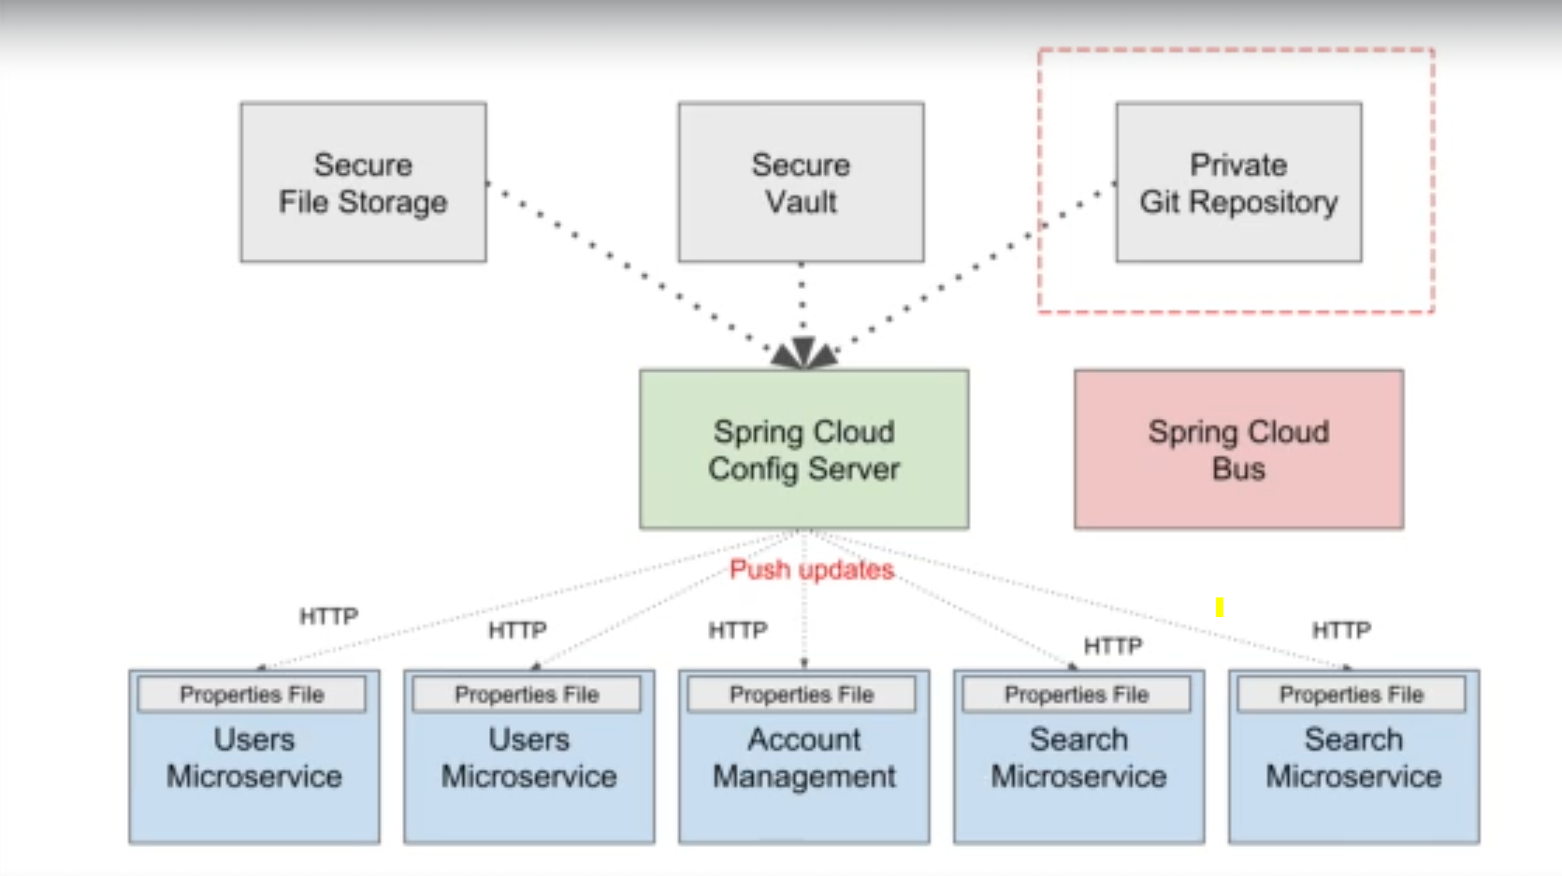

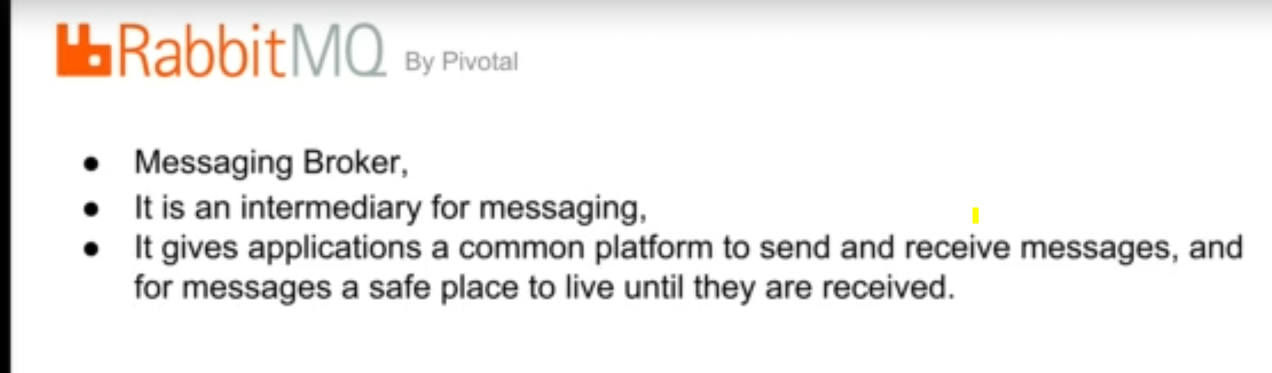

RabbitMq installation

<https://www.rabbitmq.com/docs/next/install-windows-manual>

Add below dependencies

<dependency>

<groupId>org.springframework.cloud</groupId>

<artifactId>spring-cloud-starter-bus-amqp</artifactId>

</dependency>

<dependency>

<groupId>org.springframework.boot</groupId>

<artifactId>spring-boot-starter-actuator</artifactId>

</dependency>

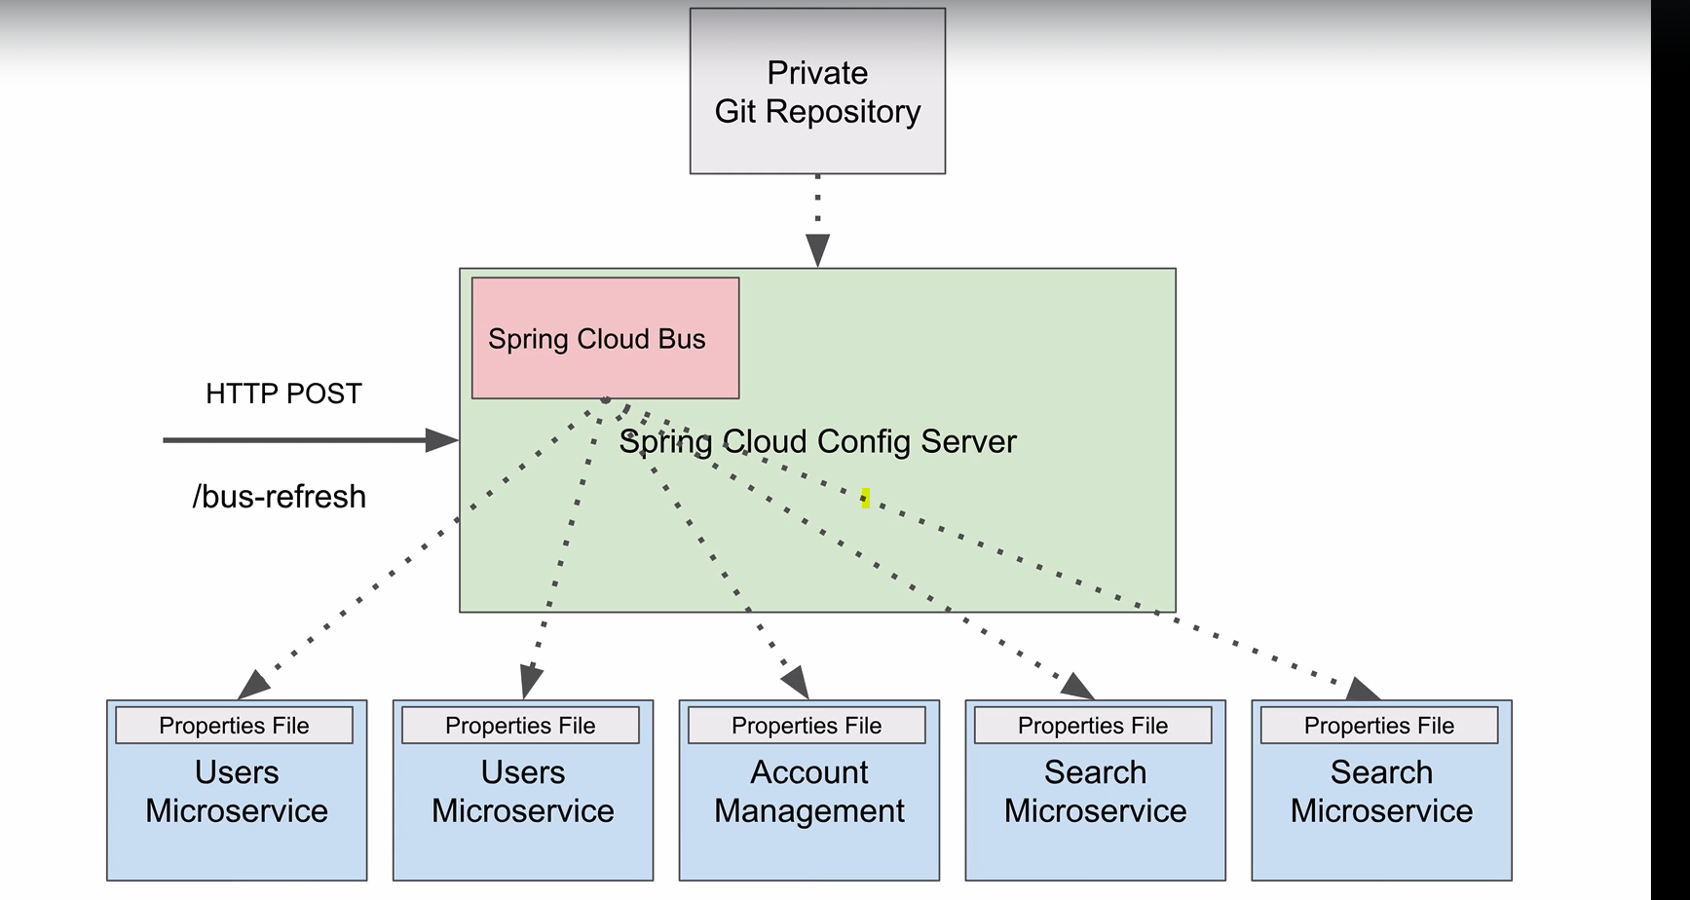

Now when ever a change is made in the properties post request is made to the cloud bus using bus-refresh. Then cloud bus will read the updated properties and will broadcast the changes to the subscribed microservices.



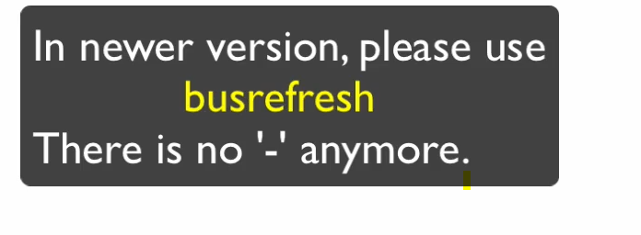

After starting the rabbitmqserver config the properties ad below.

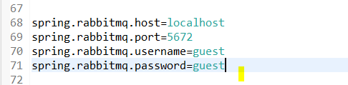

After adding this properties use service bus to broadcast the changes.

To broadcast changes we need to use below url

<http://localhost:8290/actuator/busrefresh> as POST request

when this url is triggered then automatically changes which are made in the config server will be broadcasted to the all services.

### Change rammitmq default password

Go to admin and user and change password.

For spring config server git repository is used for reading the global properties. Same way instead of git we can use file system to read the global properties.

spring.profiles.active = native

for using the file system we need to adda bove property .

if we need to use git we can change above property as

spring.profiles.active = git.

If we need to use both file and git then use below.

spring.profiles.active = native, git

also add the path where the properties file is available as shown below.



Next we have created file with below name in config server properties

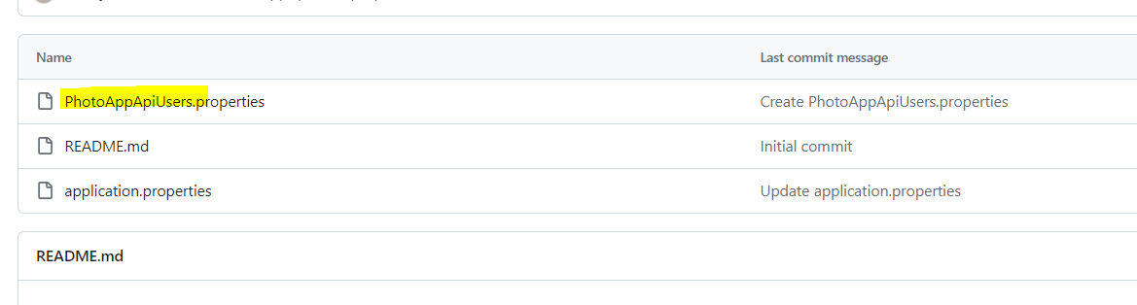

That specific service to use that properties file we need to update the bootstrap file and inform whih file I need to use.

In bootstrap file provide the name as below

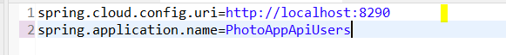

After abov configuration the usermicroservices will use the properties from the photoappapiusers.properties and application.properties in config serve and application.properties from the users service.

If property is duplicated in these files then priority based itwill use.

<http://localhost:8290/configserver/default>

using aabove get request we can read the properties files information.

# Spring boot actuator

Used to monitor and mange the apringboot application.

Used to get the status of the application. /health – health check

/beans – gets the list s of beans available in the service

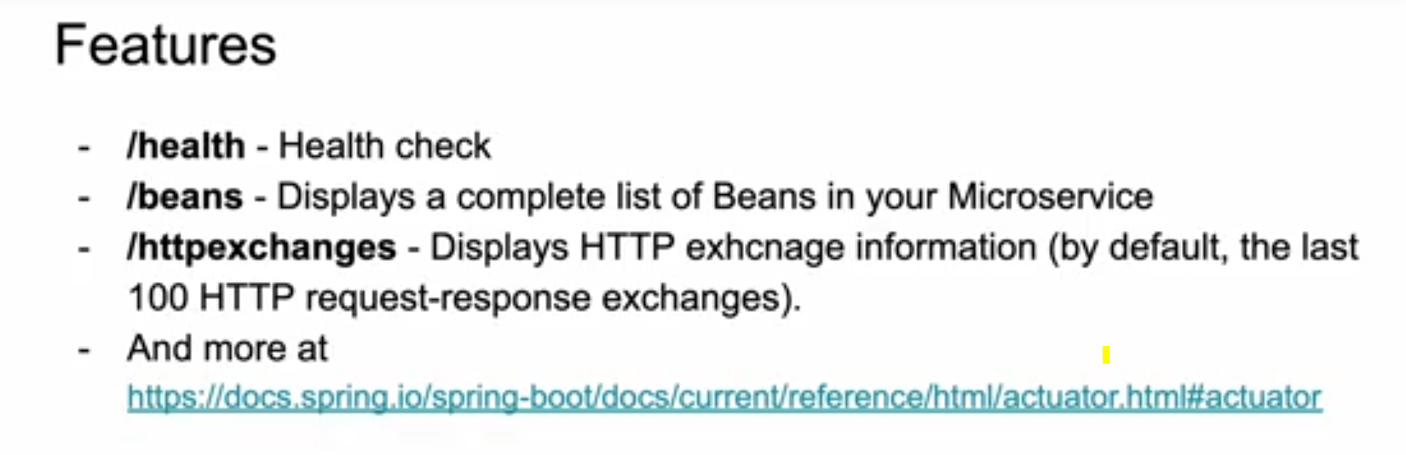

For adding actuator add the actuator dependency.

We need to enable the actuator by adding additional configuration.

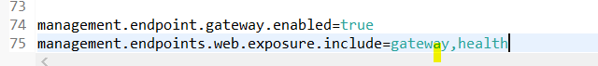

We need to provide the endpoints which we need to enable as shown above.

If we need to enable all the end points then use *.

Sample urls to check using actuator

<http://desktop-5bihmil:8082/actuator/gateway/routes>

<http://desktop-5bihmil:8082/actuator/mappings>

<http://desktop-5bihmil:8082/actuator/health>

**Actuator Documentation Links**

Below are links to official Spring Documentation. You can use these links to learn more about Actuator endpoints.

* [Official Actuator Documentation](https://docs.spring.io/spring-boot/docs/current/reference/html/actuator.html)
* [Spring Cloud Gateway Actuator API](https://cloud.spring.io/spring-cloud-gateway/multi/multi__actuator_api.html)

To check the actuator for the apigateway then just adding above configurations will be fine.

But if need to add the actuators for the service under the apigateway then need to add the gateway route in the gateway service as below .

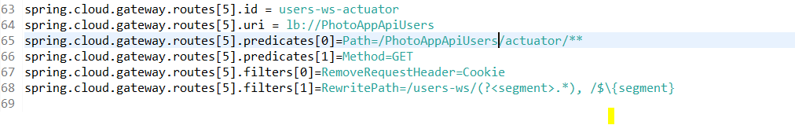

# Mysql for services

CREATE USER 'service'@'localhost' IDENTIFIED BY 'password';

grant all privileges on photo_app.* to 'service'@'localhost';

# Encrypt and decrypt configserver properties

CREATE

Spring config server supports two encryption types.

1. Symmetric
2. Assymetric

Symmetric

Assymetric

Key tool is used to encrpty and decrpty.

The Java Cryptography Extension enables applications to use stronger versions of [standard algorithms](http://docs.oracle.com/javase/8/docs/technotes/guides/security/StandardNames.html).

**Symmetric encryption**

For encrypting any word using symmetric way. Add the secret key in the bootstrap file of config server as shown below.

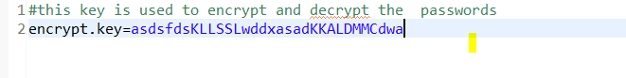

To encrypt make a post call to below url by providing the string which we need to encrypt in the body body.

<http://localhost:8290/encrypt>

same way to decrpty the string encrypted by usng above url use below url. And provide the encrypted string in the body.

<http://localhost:8290/decrypt>

Now encrypt the password and save in the properties file as below. Add {cipher} in fornt of the encrypted key

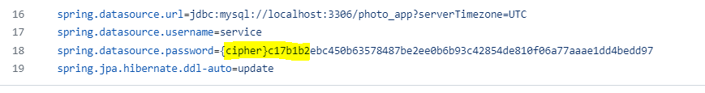

Now when we try to get the properties by using below url we will get the un encrypted password. Because config server will automatically decrypt and will return.

<http://localhost:8290/PhotoAppApiUsers/default>

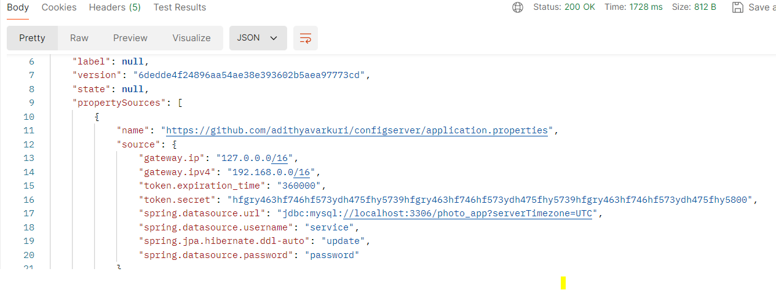

For encrypt and decrpt we need to use same key(encrypt.key) which is used in the bootstrap.properties file.

**ASymmetric encryption**

For encryption we need to generate the jks file and place the file in the folder.

Below command is used to generate the jks file.

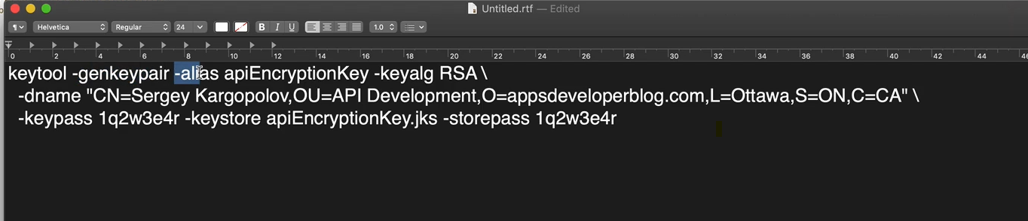

And provide the properties like file location of jks file and password for the encryption and key

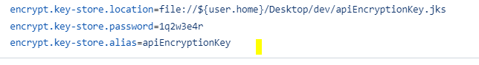

After configuring this by using same endpoints we can encrypt and decrypt the strings.

<http://localhost:8290/encrypt>

<http://localhost:8290/decrypt>

# Micro services communication

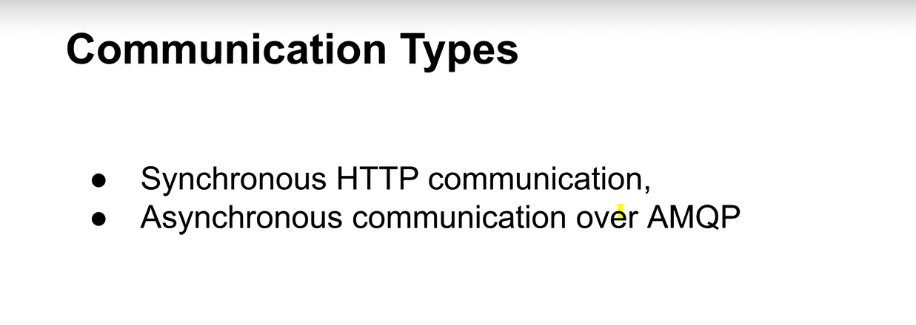

Asynchronous means we will send the request from one service to another service and leaves therequest.

We will end the request to the queue and the destination service wil be subscribed to that queue and when ever a new request comes into queue the service will consume that and pocess it .

Synchronous means send the request from one service to another service and wait until we get the response from the service.

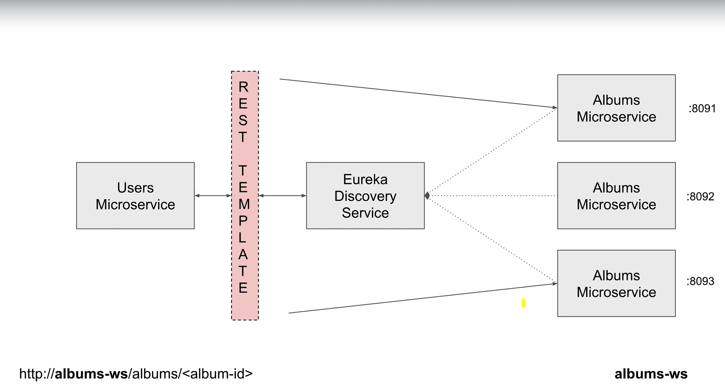

In above image users service will send request to the albums service and albums service will process and will send the response back to the users service. Here users service will wait until it gets the response from the album service.

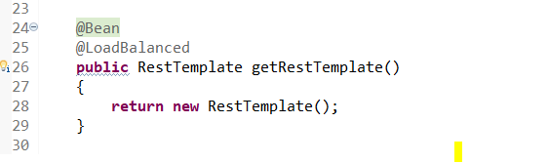

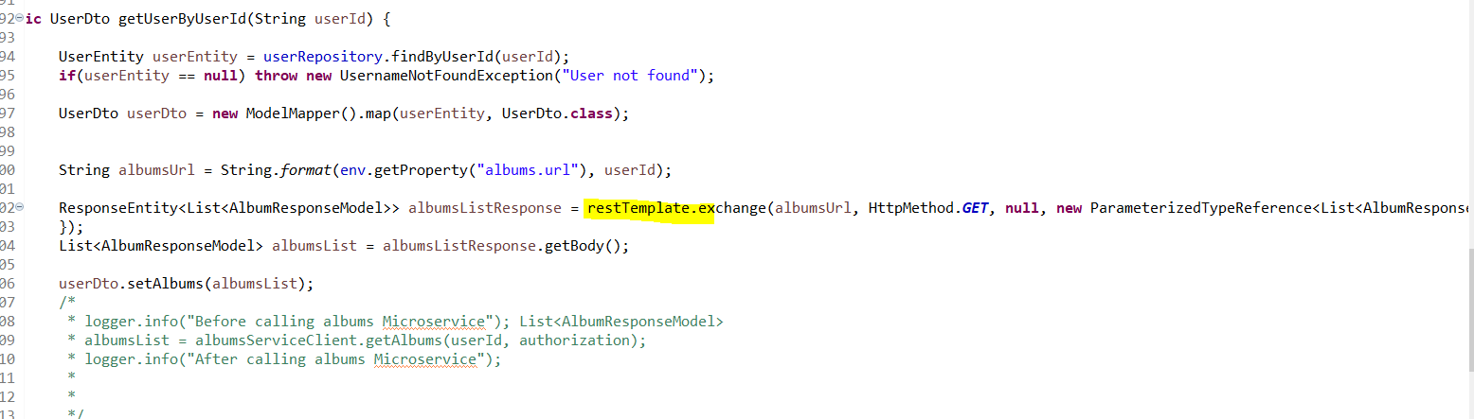

Using resttemplate make a call to the service.

## Feign webservice client

Feign is same like resttemplate used to send request to remote or internalmicroservice and get the response.

To use feign need to declare the serice endpoint as below. Creat interface.

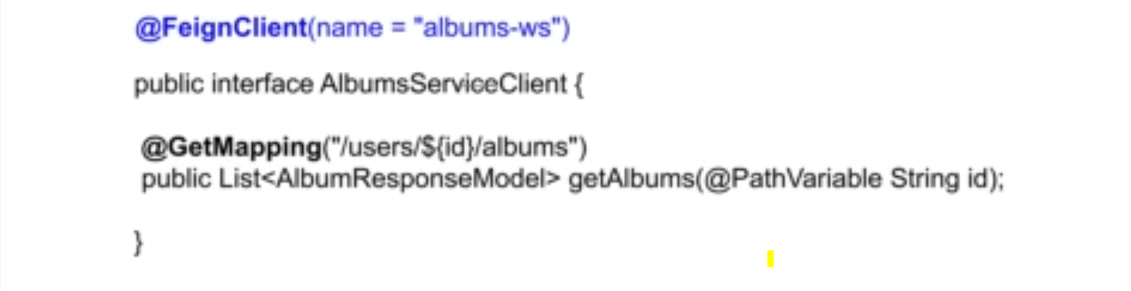

If we need to send request to eexternal then use below

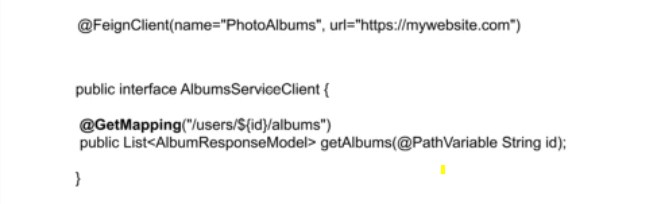

Add beow dependency

<dependency>

<groupId>org.springframework.cloud</groupId>

<artifactId>spring-cloud-starter-openfeign</artifactId>

</dependency>

From the application which we need to make external service call annotate as below. @EnableFeignClents.

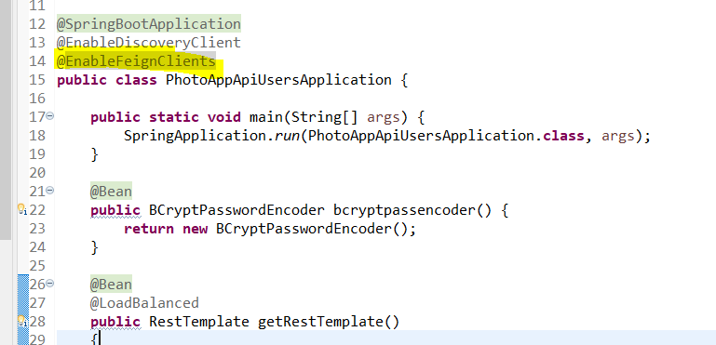

Create feign client interface

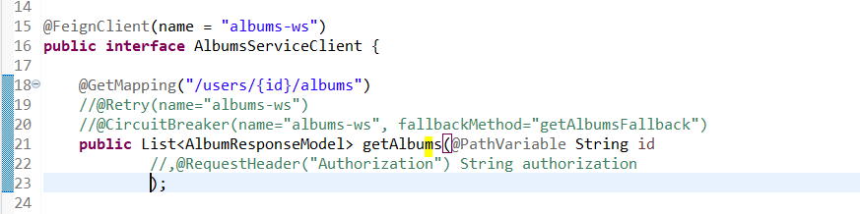

Call the method directly

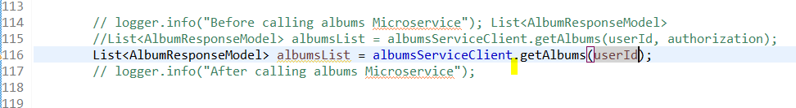

You can add the feign logger for this add this in applicaion

@Bean

Logger.Level feignLoggerLevel()

{

**return** Logger.Level.***NONE***;

}

Using try catch handle the error.

Another way to handle the exception is

Create feignerrordecoder

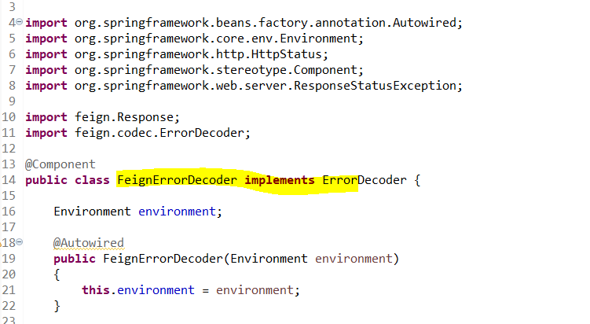

In the decode method add the status and for each status can add exception and return responsestatusexcetpton.

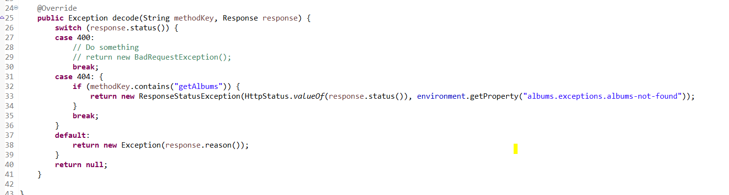

## Hystrix Circuit Breaker (deprecated)

When we make a call to another microservice from one service then what if the other service is down. If service is down we wont get result.

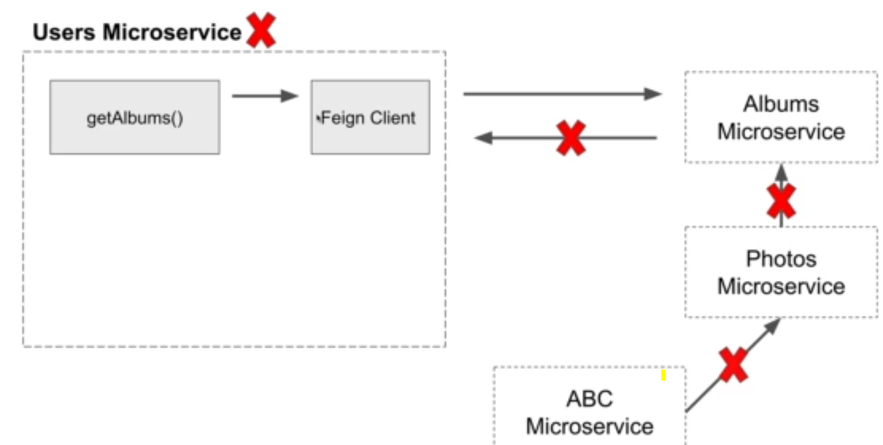

As shown in above image if we are making inter microservice communications then if one service fails then other services which are dependent on it will fail.

In this case circuit breaker will call the the fallback method which we write and that method will return the hardcoded values.

Once the albums service is up and running then feign will again route the requests to albums service.

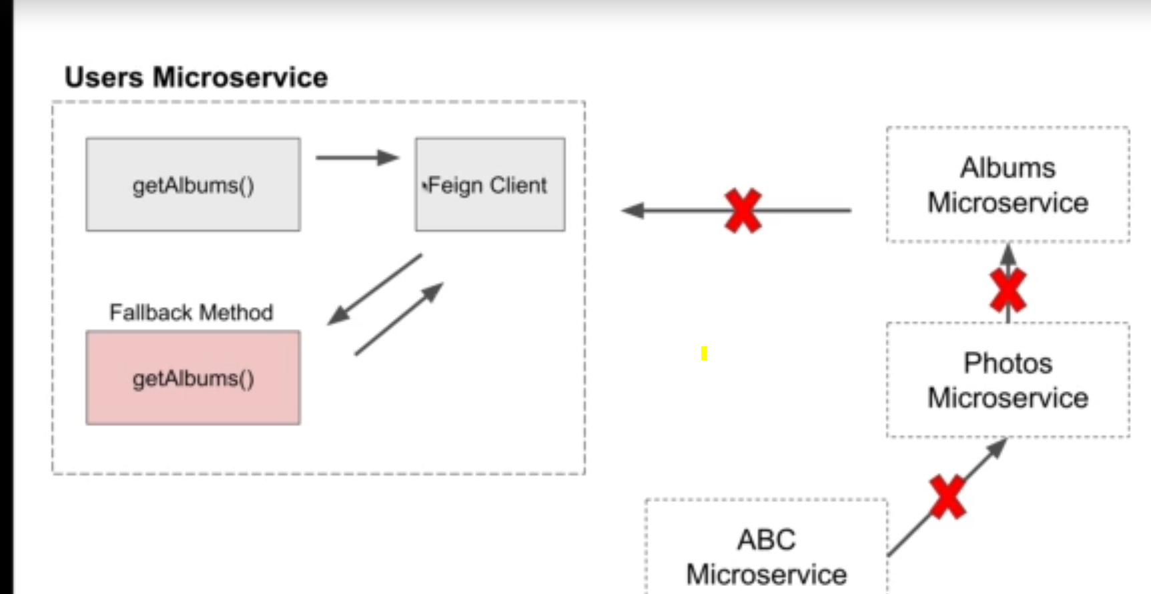

## Resilience4j – circuit breaker

As hystrix circuit breaker is deprecated so instead of hystrix will use Resilience4j circuit breaker.

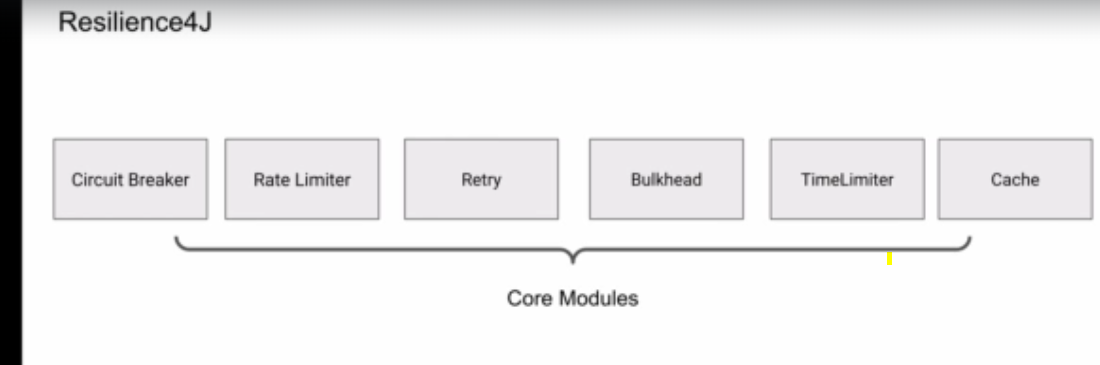

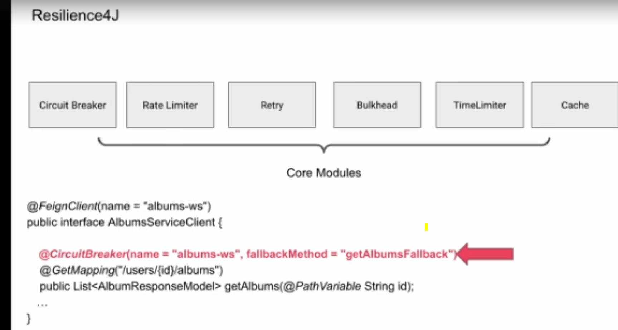

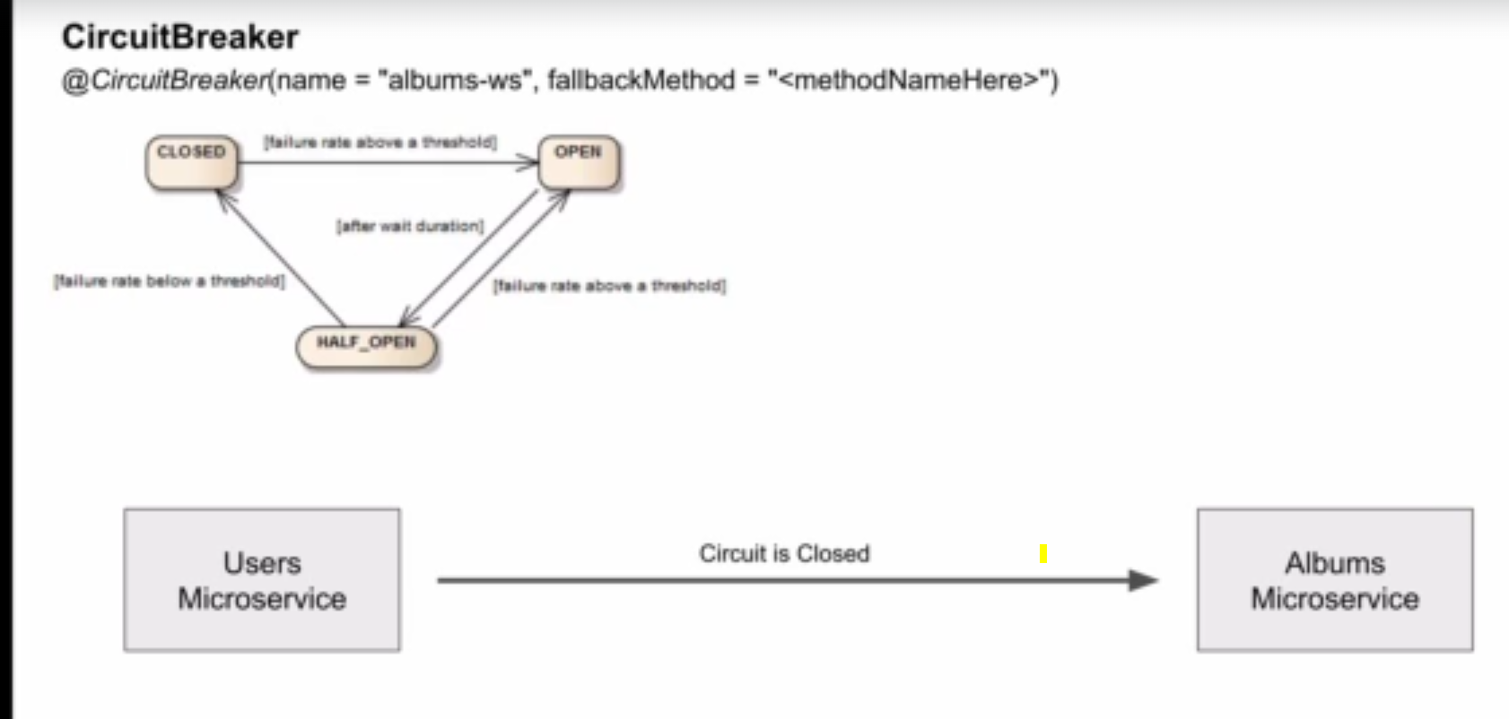

When circuit breaker is closed it means the request will go to the albums (main) service and will get the response from the service.

When circuit is in open state it means the main album service is down so it will call the fallback method and returns the hard coded response.

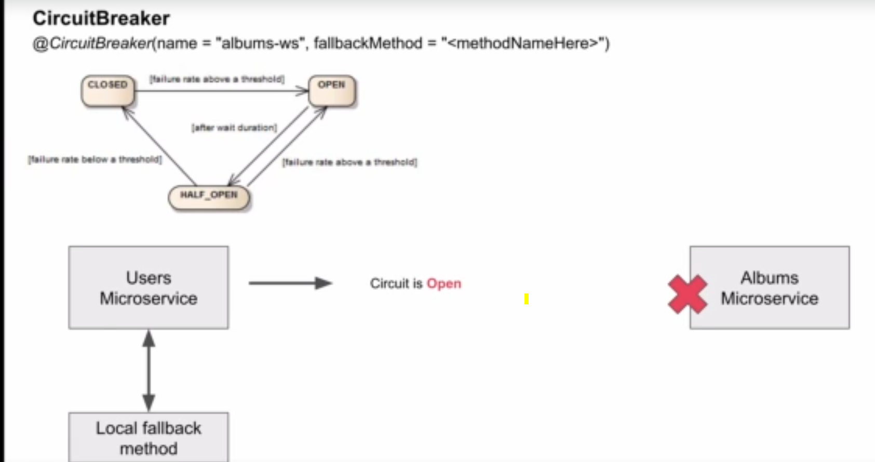

We will provide the time period in propertiesfile and after that time period the circuit breaker will goes to Half_open state and will once again try to access the albums service. And if still the service is down then circuit breaker will again goes into open state and will use fallback method.

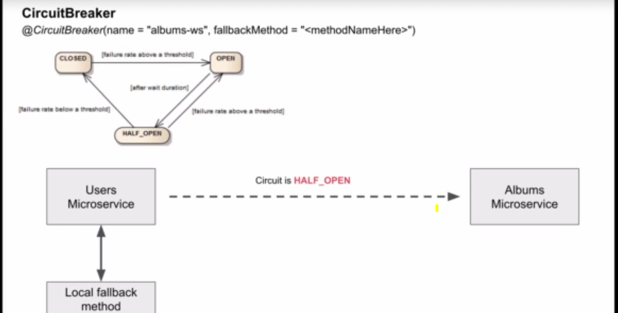

**BulkHead**

It is used to configure that how many concurrent calls can be made to the feign client configured url.

We can either use the properties file and annotate as bulkhead or we can use code configuration as shown below.

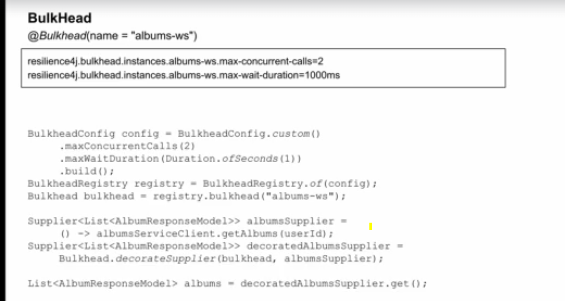

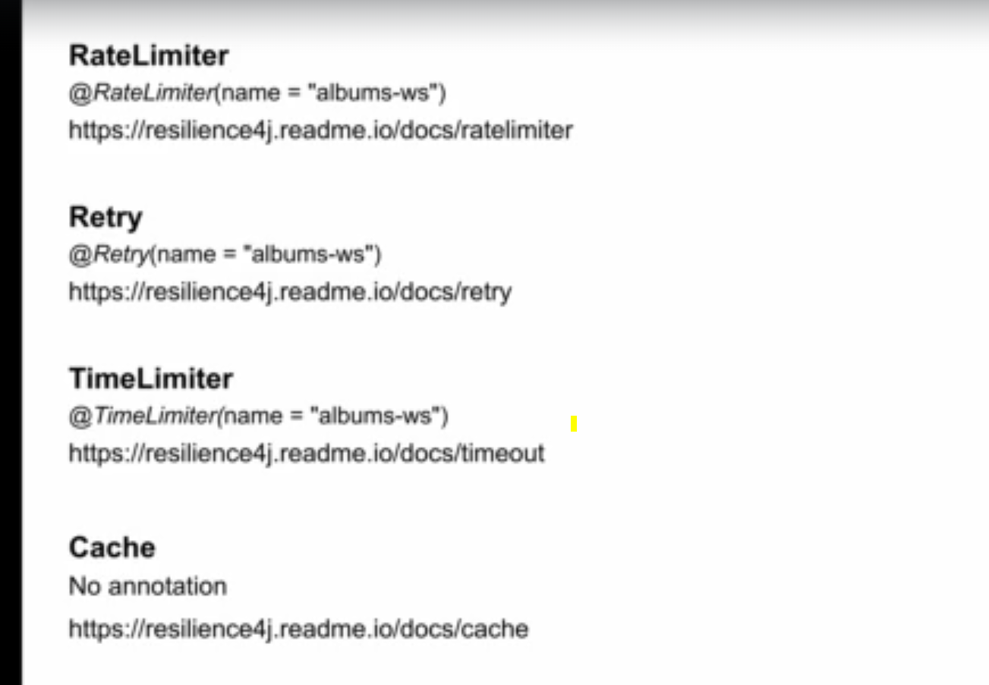

Rate limiter is used for limiting the requests for specific time period. Like only 10 requests for 10 min or 1 request for 1 sec etc.

Retry. Once the other service is down then do I need t retry the same call. And we can also configure like after howmuch time I can make a retry.

TimeLimiter is like timeout. Howmuch time I need to wait for response. And after howmuch time I need to call the fallback function.

Add below dependencies

<dependency>

<groupId>io.github.resilience4j</groupId>

<artifactId>resilience4j-spring-boot2</artifactId>

</dependency>

<!--

https://mvnrepository.com/artifact/org.springframework.boot/spring-boot-starter-aop -->

<dependency>

<groupId>org.springframework.boot</groupId>

<artifactId>spring-boot-starter-aop</artifactId>

</dependency>

For adding circuit breaker add below configuration with fallback method. And add the fallback method.

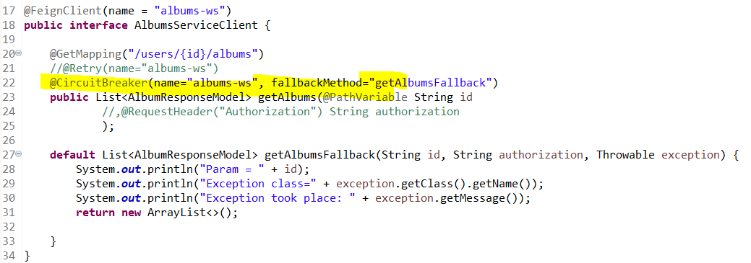

Below properties are used for circuit breaker.

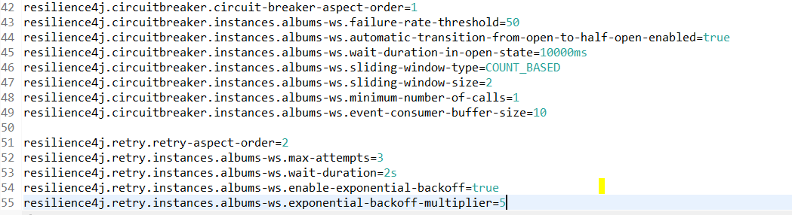

Failure rate- while sending the request to remote service and if failure rate is greater than the provided failure rate then circuit breaker will open, it means it will route to fallback method.

This albums-ws should be matched with the name provided in the circuit breaker

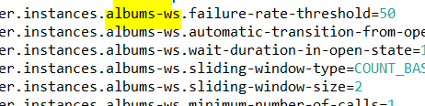

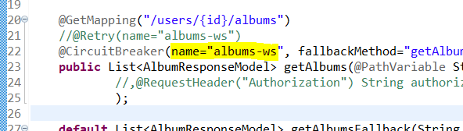

Wait-duration – CB should wait for wait duration time before it opens.

***What is count based circuit breaker ?***

The sliding window that determines whether the circuit should be open is decided based on the outcome of the last ’N number of calls’ (i.e the sliding window size we have set)

If we have set the number of calls in the sliding window to 10 (i.e sliding window size is 10). And if the last 10 calls fails, then the circuit shifts to open state. This is without setting any other threshold values.

1. **failureRateThreshold —**When the failure percentage of our sliding window is equal to or greater than the threshold, the Circuit Breaker changes to open state. Let’s take an example, if our sliding window size is set to 10 and the **failureRateThreshold**is set to 50. Then if 5 or more calls fail in the 10 calls that were made, then it is changed to open state

<https://medium.com/@rachel883omega/implementing-count-based-circuit-breaker-in-java-5bcab82014ae>

minnumof calls – min calls required to record.

To monitor the circuit breaker events use below url.

<http://localhost:8082/Photoappapiusers/actuator/circuitbreakerevent>.

Above url is used to get the status of the circuitbreaker and exceptions and last events.

Retry annotation

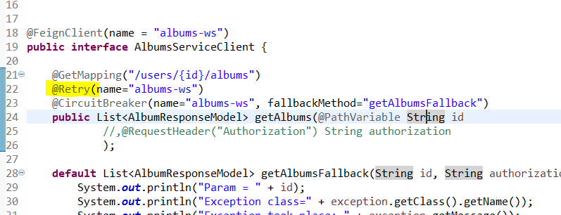

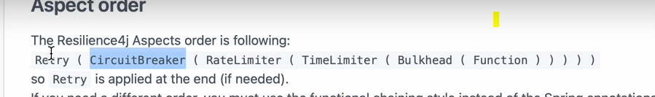

This is the order in whch it is applied.

## Micrometer and Zipkin

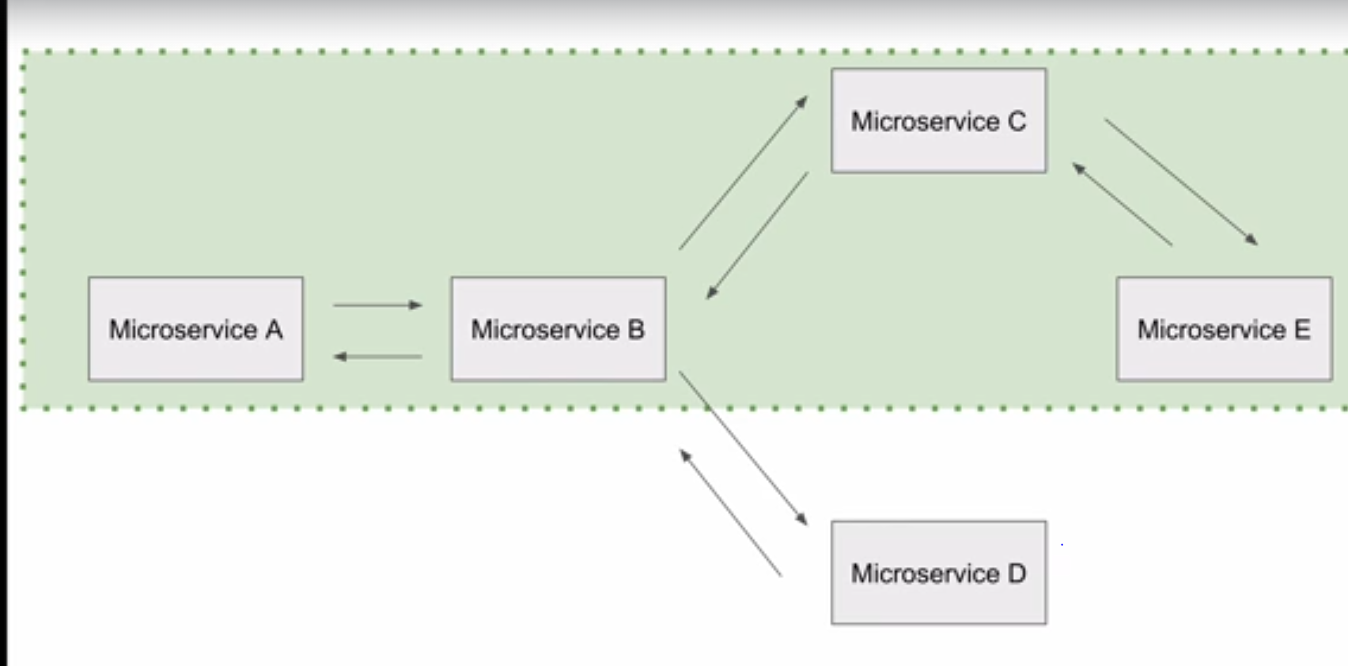

If there are multiple microservices, we need to make calls between microservices and flow can be like from service a to b to c to d. we get the final result. But if any service fails in between we will get the final exception. But we don’t know in which service it has been failed. So we need to trace the request. By using Micrometer and zipkin we will trace the request.



Micrometer is used to collect the information and zipkin is used to display the information.

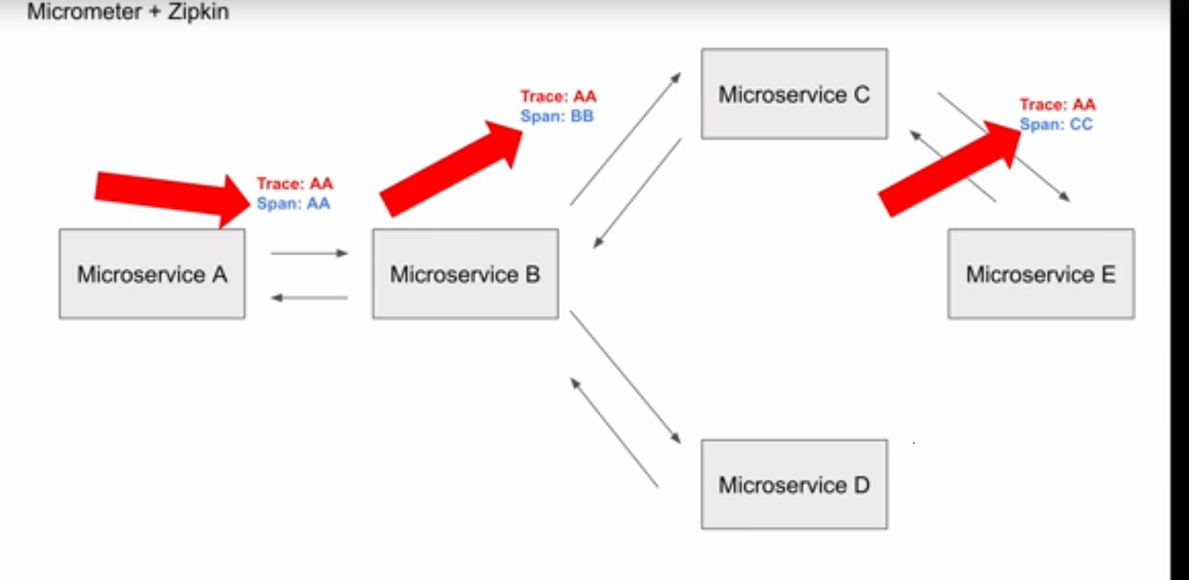

To track the request we will use spanid and trace id.

Span id will be different for each request made among the microservices as shown in above img.

Traceid will be same for one request through out the flow.

How to start zipkin

<https://zipkin.io/pages/quickstart.html>

Add dependency

<!-- https://mvnrepository.com/artifact/io.micrometer/micrometer-observation -->

<dependency>

<groupId>io.micrometer</groupId>

<artifactId>micrometer-observation</artifactId>

<version>1.12.4</version>

</dependency>

<!-- https://mvnrepository.com/artifact/io.micrometer/micrometer-tracing-bridge-brave -->

<dependency>

<groupId>io.micrometer</groupId>

<artifactId>micrometer-tracing-bridge-brave</artifactId>

<version>1.3.3</version>

</dependency>